Nanostructured Composites Based on Interpenetrated Polymer Networks
Nonisocyanate Polyurethanes Based on Cyclic Carbonates and Nanostructured Composites
Part II
O. Figovsky, D. Beilin, A. Leykin

Polymate Ltd.-International Nanotechnology Research Center,
Migdal HaEmek, Israel

Abstract: Recent advances in chemistry and technology of nonisocyanate polyurethane (NIPU) materials based on cyclic carbonate oligomers are reviewed in this paper. Reaction of the cyclic carbonate and amino groups results in β-hydroxyurethane fragments with specific properties. Primary attention is given to the hybrid materials that contain epoxy and acrylic compounds, especially materials based on renewable raw materials. Hybrid organic composites comprising of silanes are also considered. An overview of the recent publications in this field is provided with a more detailed description of achievements by the authors and their corporate employees. The use of NIPU materials as coatings, adhesives, and foams is described.
Key words: nonisocyanate polyurethanes, cyclic carbonate oligomers, hybrid polymers

Continued
Hydroxyurethane compounds from renewable plant-based raw materials
In contrary to the polymerization of carbonate ring containing monomers, molecules containing multiple cyclic carbonate rings are also available by an addition of carbon dioxide to the appropriate multi-epoxy compounds. The largest class of such reagents is epoxidized vegetable oils or their derivatives like fatty acids or their dimers [35]. The reports on carbonation of epoxidized vegetable oils are in most cases based on similar procedures using comparable catalytic systems and reaction conditions (Table 6 [35]).
Table 6
The reaction conditions of carbonation of epoxidized vegetable oils
No. | Expodized vegetable oil | Carbonation condition
1 | 2 | 3
1 | Soybean Epoxol 7-4 | TBAB* (2.5 mol% per epoxy groups) CO₂ (5.65 MPa), 22 hr, 140ºC
1 | 2 | 3
2 | Soybean Shanxi Chemical Factory, China | TBAB and SnCl₄·5H₂O (2.5 mol% per epoxy groups) CO₂ (high pressure), up to 30 hr, 140ºC
3 | Soybean (ESO, Vikoflex 7170) Arkema | TBAB (5.9 MPa), 46 hr, 140ºC
4 | Vernonia oil Vertech, Inc | TBAB (5.9 MPa), 46 hr, 140ºC
5 | Soybean, Flexol EPO, Dow Chemical | TBAB (1.25-5 mol% per epoxy groups) CO₂ (5.65 MPa), 110-180ºC
6 | Fatty acids dimers from sunflower oil | TBAB (3 wt %) CO₂ (5MPa up to 18.5 MPa), 60-140ºC
7 | Soybean oil Paraplex G-62 from CP.Hall Co. | TBAB (5 mol% per epoxy groups) CO₂ (medium flow), 70 hr, 140ºC
8 | Soybean oil from Cognis | TBAB (3 mol% per epoxy groups) CO₂ (1 MPa), 20 hr, 140ºC
9 | Linseed oil (ELSO from HOBUM Oleo chemical | TBAB (3 mol% per epoxy groups) CO₂ (1 MPa), 20 hr, 140ºC
10 | Soybean oil NOPCO Colombiana | TBAB (3-7 mol% per epoxy groups) CO₂ (continuous flow), 100-140ºC. microvawes, 40-70 hr
11 | Soybeanoil VIKOFLEX 7170 from Atofina | TBAB or TBAOH**CO₂ (3.4 MPa), 100ºC
12 | Cottonseed XinjjlandWulumuqiXinsai Oil & fat Co., Ltd, China | TBAB (1.25-6 mol% per epoxy groups) CO₂ (1-3 MPa), 100-150ºC
13 | Soybean oil from Cognis Turkey | TBAB, CO₂ (0.45 MPa), 12 hr, 110ºC
14 | Inseed oil (Dehysol B316) from Cognis GmbH | TBAB (5 mol% per epoxy groups) CO₂ (medium flow), 72 hr, 110ºC
*TBAB-Tetrabutylammonium bromide
**TBAOH -Tetrabutylammonium hydroxide

Authors and their collaborators proposed a new method of producing a hybrid polyhydroxyurethane network comprising of [36]:
- Reacting epoxidized unsaturated fatty acid triglycerides with carbon dioxide in the presence of a catalyst to obtain carbonated-epoxidized unsaturated fatty acid triglycerides, wherein conversion of oxyrane groups to 2-oxo-1,3-dioxolane groups (cyclic carbonate groups) for said carbonated-epoxidized unsaturated fatty acid triglycerides ranges from 35 % to 85 % (Fig.5);
- Mixing and reacting the carbonated-epoxidized unsaturated fatty acid triglycerides with a compound having an amine functionality comprising at least one primary amine group realized at stoichiometric or within nearly balanced stoichiometry;
- Mixing and reacting the product of (b) with a compound having amine functionality comprising at least two primary amine groups realized at excess of an amine-functional compound;
- Mixing the product of (c) with a compound having amino-reactive groups and selected from the group comprising:
- Acompound having epoxy functionality, and
- A mixture of the compound having epoxy functionality with carbonated-epoxidized unsaturated fatty acid triglycerides, a ratio of the sum of amino-reactive groups to the sum of amine groups being stoichiometric or within nearly balanced stoichiometry;
- Curing the resulting composition at ambient temperature.

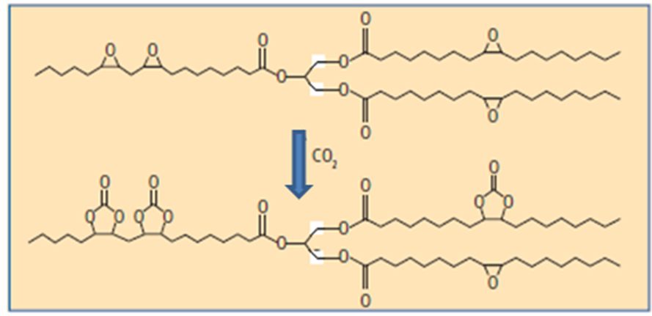

Fig.5. Obtaining carbonated epoxidized unsaturated fatty acid triglycerides

The proposed method can significantly reduce time of synthesis and improve quality of the final products.

Silane-containing and nano-structured hydroxyurethane compounds
The concept of generating silica from alkoxysilanes by the sol-gel method within a macromolecular organic phase (in situ) is widely known in the art. The organic and inorganic components of these materials are present as co-continuous phases of a few nanometers in lateral dimensions. Earlier authors have studied new types of NIPUs based on cyclic carbonate-epoxy resin systems and aminoalkoxysilanes [37]. The proposed dendro-aminosilane hardeners give the possibility for the introduction of siloxane fragments into the aromatic structure of BPA epoxy-amine and cyclocarbonate network polymers which improves the service properties of the network polymer. Additional hydrolysis of organosilane oligomers creates a secondary nanostructured network polymer.
Known in the art as hybrid organic-inorganic compositions include mixtures of epoxy resins, amine hardeners, functional silanes, and/or polysiloxanes and cure in the presence of water in an amount sufficient to bring about substantial hydrolytic polycondensation of the silane [18].
A novel nano-structured hybrid polymer composition was synthesized on the base of epoxy-functional components, cyclic carbonate components, amine-functional components, and acrylate (methacrylate) functional components, wherein at least one epoxy, amine, or acrylate (methacrylate) component contains alkoxysilane units [38]. The composition is highly curable at low temperatures (approximately 10 - 30 °C) with generating nanostructure under the influence of the forming of active, specific hydroxyl groups by reaction of cyclic carbonates with amine functionalities.
These hydroxyurethane functionalities activate by hydrolytic polycondensation of alkoxysilanes by means of atmospheric moisture, thus producing an organic-inorganic nanostructure without a special procedure of water embedding or addition of nanofillers. The cured composition has excellent strength-stress properties, adhesion to a variety of substrates, appearance, and resistance to weathering, abrasion, and solvents (Fig.6).
Sprayable foam
The vast majority of methods for the application of sprayable polymer foams onto various substrates use air or airless spraying equipment. The main advantage of these methods is the rapid formation of a polymer structure to obtain non-flowing foam on vertical surfaces. However, non-isocyanate resin foams require some other approach since they exhibit longer durations of gelation and solidification, which can lead to flow on vertical surfaces and a collapse of the foam. Olang [39] disclosed hybrid spray foams that use a urethane reactant, a crosslinker, and an (optional) epoxy and/or acrylic resin, along with a blowing agent and rheology modifier to produce quick-setting foam that remains in place until the foam forms and cures. In some other formulations the author used the NIPU adducts of cyclic carbonates and di- or poly-amines. Unfortunately, the use of rheology modifiers in practice increases the viscosity of the compositions and imparts to them for foams.
As known the foam-formation process in which a blowing agent forms cells in a resin during curing, depends on a number of factors. Most importantly are the rate of cure and the blowing gas generation rate, which must be properly matched. The aforementioned components that define a foamable nonisocyanate polymer composition form a relatively slow reacting system. At ambient temperature, the gel time of such compositions is not less than 5 min. On the other hand, premature application of the forming foam product onto a substrate must be avoided because as soon as the foam composition is applied, the foam rapidly expands, and this may cause the expanding foam to collapse as a result of inadequate strength of the walls surrounding the individual gas cells. In other words, synchronization of curing and foaming processes is a very important factor that is not provided by conventional methods of producing sprayable nonisocyanate polymer foams.

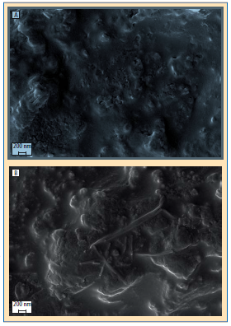
Fig.6. Images of the fractured surfaces of the curedcompositions at 20,000xmagnifi cation (Auriga Cross-Beam): A – neat epoxy-aminecomposition;B– epoxy-silane-amine composition
As noted above some non-isocyanate compositions related to hybrid systems on the basis of epoxy, hydroxyurethane, acrylic, cyclic carbonate, and amine raw materials in different combinations. Patent [40] discloses foamable, photopolymerizable liquid acrylic-based compositions for sealing applications, which include products of reaction of non-isocyanate urethane diols with methacrylic or acrylic anhydride. Patent [41] describes hybrid non-isocyanate foams and coatings on the basis of epoxies, acrylic epoxies, acrylic cyclocarbonates, acrylic hydroxyurethane oligomers, and bifunctional amines. However, all these compositions are used "in-place" (in situ) and are unsuitable for spray applications.
Sprayablenonisocyanate polymer foam composition composed of an amino-reactive component, an amino-containing component, a blowing agent, and additives. The components are separated into two parts, i.e., part (A) on the basis of an amino-reactive compound, and part (B) on the basis of an amino-containing compound.
Various mounting options provide foaming of the compositions with simultaneous application on horizontal, inclined, or vertical surfaces, or injecting the composition into voids.
Unlike conventional systems where mixing of the components occur in the mixing head of the gun, we have suggested the new method provides mixing of components and aging of the mixture.
For spray application, parts A and B are loaded under pressure into a foam-spraying apparatus (Fig.7).The installation comprises containers (1 and 3) for the components A and B of the composition, respectively, and loading meters (2 and 4) which are intended for dosing the components A and B into the mixer (5) in proportions determined for the specific composition.
The reaction between the amine-containing component A and the basic component B is accompanied by the generation of heat, which is consumed simultaneously for the activation of a polymerization reaction and evaporation of the blowing agent (when a physical blowing agent is used). The polymer formation process occurs under the quasi-adiabatic conditions [42], i.e., without heat exchange with the environment, but with continuous movement of the reaction mass. In accordance with the above-described conditions, the temperature in the intermediate chamber (6) well correlates with the degree of chemical conversion of the reaction mass and, consequently, with the strength of the cell walls of the foam and their ability to retain the blowing agent.
Although in the description of this apparatus the constituents A and B are called "components", in fact, each such component may consist of several sub-components. For example, the first component A, which comprises an amino compound as an active ingredient, an integral component may also contain a foaming agent, surfactant, or other additives (accelerators, dyes, etc.). The second component B representing a base composition, i.e., an epoxy-cyclocarbonate component, may also contain various additives for adjusting the final properties of the foam.
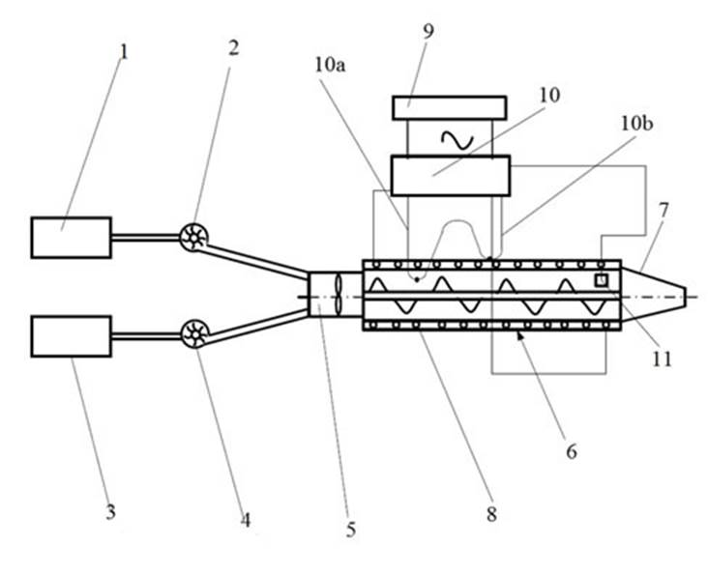
Fig.7. Schematics of the laboratory installation for preparing and spraying HNIPU: 1- container for component A; 2 - dispensing device for loading the component A; 3 - container for component B; 4 - metered loading device for component B; 5 - mixer; 6 - intermediate chamber; 7 - discharge nozzle; 8 - heater; 9 power supply; 10 - temperature control unit; 10a-10b - differential thermocouple; 11 - temperature sensor

With dosing meters componentsA and B are delivered in predetermined proportions to the mixer (5) where the components are uniformly mixed and begin to react with each other. From the mixer (5), the reaction mixture is transferred to the intermediate chamber (6) through which the reaction mixture flows to a spraying device (7).
In the intermediate chamber the chemical process of polymer formation occurs under quasiadiabatic conditions, i.e., without heat exchange with the environment, and with continuous movement of the reaction mass. Under such conditions, the temperature is well correlated with the degree of chemical transformation and, thus, with the strength of the walls of the foam cells and their ability to retain the blowing agent.
The residence time of the reaction mixture in the chamber (6) is defined specifically for each composition and depends on the curing reaction rate and the nature of the blowing agent. The estimated residence time of the composition in the chamber (6) should provide a predetermined period needed for completing the curing reaction and forming foam directly on the insulated surface.
As a result of delay in the chamber the mixed composition reach of the state necessary for spraying. The residence time of the mixture in the chamber and the heating temperature are controlled based on the rate and the exothermic of the curing reaction as well as the boiling point of blowing agent.
Thus, the temperature of the composition in the intermediate chamber may serve as a parameter most suitable for optimal control of the foam formation process in spray application. During the heating of the reaction mixture it becomes possible to reach the boiling point of the blowing agent, and the mixture acquires properties necessary for foaming the composition after spraying the latter onto the insulation surface. If conditions during residence of the reaction mixture in the intermediate chamber (6) are adjusted correctly, the foam applied onto the treated surface is obtained without defects and provides the required parameters.
To ensure quasi-adiabatic conditions, in addition to thermal insulation, the intermediate chamber (6) is provided with a heating system. Such an additional heating system may comprise a heater (8), for example, a resistive heater powered from a power source (9) connected with the heater (8) via a temperature control unit (10). A temperature control unit (10) includes a differential thermocouple and a temperature sensor for determining the temperature required to foam the mixture at the outlet of the intermediate chamber (6). One junction (10a) of the thermocouple assembly is located within the intermediate chamber, and the other junction (10b) is located on an insulated outer wall of the intermediate chamber (6). Turning on and off the heater (8) depends on the temperature difference between the two thermocouple junctions (10a, 10b).
It is important to note that in order to ensure continuity of the foam application process, operations associated with mixing, component supply, and mixture delivery must be strictly coordinated for continuity of the flow of the material from the loading device to the spray device (7).
In various embodiments, the installation may also include supply of compressed air, which may be required, for example, for purging the mixer (5), the intermediate chamber (6), and the exit nozzle (7) after the foam formation and application process are completed. The loading devices (2 and 4) may comprise, for example, metering pumps.
The authors and their colleagues developed a basic formulation and technique for mixing and foaming insulating spray foam and a procedure for obtaining conventional foams have been updated in respect to HNIPU application
. Technical specifications of this newly developed composition correspond to the mean values of a similar urethane-based thermal insulation. The ultimate strength of the new material is about 1.5 times higher than that of the polyurethane foam, and the heat-insulating properties are at the same level as in polyurethane foam with open cell structures. The possibility of application by spraying was tested on pilot equipment.
The composition of the foam was studied with regards to the use of renewable raw materials, including new HUM. As a result, hard and elastic foams were obtained with properties not inferior to polyurethane foams (Table 7).

Table 7.
Rigid HNIPU foam
Properties | Standard | Rigid foam
Viscosity (Brookfield RVDV II, Spindle 29, 20 rpm) at 25 °C, cP  - Base “A”  - Base “B”  - “A” + “B” (3-5 s after mixing) | ASTM D2393 | 2,800 – 3,200  3,600 – 4,100  ≤ 3.700
Pot life at 25 °C (77 °F), s |  | 8-10
VOC | ASTM D2369 | Compliant
Gel time, s |  | 2-4
Touch dry, s |  | 30-40
Curing for transportation, min |  | 15-20
Appearance of rigid foam |  | White
Compressive properties of rigid cellular plastics, 24 h , MPa | ASTM D1621 | 0.2-0.4
Apparent density of rigid cellular plastics, kg/m³ | ASTM D2369 | 30-40
Thermal transmission properties,  h·ft²°F /Btu.in | C 518 | 4.5-5.0

Comparison properties of conventional polyurethane and HNIPU foam are given in Table 8.

Table 8.
Comparison physical properties of conventional insulation SPF and HNIPU foam
Characteristics | Conventional SPF | HNIPU
Apparent density, kg/m³ | 30-100 | 30-70
Breaking stress, MPa | 0.15-1.0 | 0.17-1.2
Thermal conductivity, W/m*К | 0.8-1.0 | 0.8-1.0
Number of closed cells, not less % | > 90 | > 60
Hygroscopic property, vol.% | 2.0.-3,5 | 2.5-3.5
Possibility of practical use | Depends on the purpose of the premises | No limitations

It can be seen from Table 8 that strength and thermal-insulation properties of the newly developed foam are not inferior to conventional SPF of the same class.
The creation of new insulating foam compositions based on HNIPU challenged us to simultaneously develop new technologies for the production and application of this new foam. Novel method of obtaining and applying foam is based on maximum use of standard, conventional equipment, but suggests the development of some new structural components. Such additional components address specific chemical reactions that occur during the curing of these new compositions, which provide sprayed insulation layers with industry standard characteristics for insulation in building structures.
The authors believe that further developments in the field of poly-hydroxyurethanes, that offer the most promising directions for future research include:
- Creation of production of polyfunctional cyclocarbonates, development of optimal technology and equipment: carbonized vegetable oils and terpenes; carbonized aliphatic compounds, including chlorinated ones; and carbonized polyfunctional silicones.
- Development of waterborne HNIPU formulations.
- Development of NIPU formulations for sealants and adhesives.
- Development of production of amines modified with hydroxyurethane groups.
- Elaboration of non-amine RT curing agents for oligomer compositions.
- Development of self-extinguishing compositions of HNIPU.
- Development of silicone-based HNIPU.
- Development of NIPU and HNIPU-based foams.
- Development of formulations for UV-cured compositions.

References
- Figovsky O., Shapovalov L. Cyclocarbonate Based Polymers Including Non-Isocyanate Polyurethane Adhesives and Coatings. Encyclopedia of Surface and Colloid Science, V. 3, 1633 – 1653. NY, Taylor & Francis, 2006.
- Figovsky O., Beilin D. Advanced Polyner Concretes and Compounds, CRC press, Taylor& Francis, 2014.
- Figovsky O., Shapovalov L., Leykuin A., Birukova O., Potashnikiova R. Recent Advances in the Development of Nonisocyanate Polyurethanes Based on Cyclic Carbonates, PU Magazine, vol.10, no.4, 2013, pp. 256-263.
- Figovsky O., Beilin D. Nanostructured Composites Based on Interpenetyrated Polymer Networks: Kinds, Classification, Properties, Synthesis, Application. Inženernyj vestnik Dona (Rus), 2015, no.3, Url: ivdon.ru/ru/magazione/archive/n3y2015/3113
- Figovsky O., Shapovalov L., Leykin A., Birukova O.,Potashnikova R.. Progress in Elaboration of Nonisocyanate Polyurethanes Based on Cyclic Carbonates. Inženernyj vestnik Dona (Rus), 2014, no.3. Url: ivdon.ru/ru/magazine/archive/n3y2014/2530.
- Figovsky O., Shapovalov L., Leykin A.,Beilin D.. Nanostructured Hybrid Nonisocyanate Polyurethane Coatings, Proceeding of PPS Americas Conference, Niagara Falls, Ontario, Canada, May 21-24, 2012, pp.396-397.
- Yagund E. M., Maklakov L. I., Stroganov, V. F., Savchenko V. N. Studies of Hydrogen Bonds in Model Urethane Compounds Obtained by the “Cyclocarbonate – Amine” Reaction, J. Appl. Spectroscopy, 1987, 45 (1), 737 – 741.
- Tomita H., Sanda F., Endo T. Structural Analysis of Polyhydroxyurethane Obtained by Polyaddition of Bifunctional Five-Membered Cyclic Carbonate and Diamine Based on the Model Reaction. J. Polymer Sci. A, 2001, 39, 851 – 859.
- Zabalov M. V., Tiger R. P., Berlin A. A. Reaction of Cyclocarbonates with Amines as an Alternative Route to Polyurethanes: A Quantum-Chemical Study of Reaction Mechanism.Doklady Chemistry, 2011, 441 (2), 355 – 360.
- Zabalov M. V., Tiger R. P., Berlin A. A. , Mechanism of Urethane Formation from Cyclocarbonates and Amines: A Quantum Chemical Study. Russian Chemical Bulletin, 2012, 61 (3), 518 – 527.
- North M., Pasquale R., Young C., Synthesis of Cyclic Carbonates from Epoxides and CO₂.Green Chem., 2010, 12, 9, 1514 – 1539.
- Pescarmona P. P., Taherimehr M., Challenges in The Catalytic Synthesis of Cyclic and Polymeric Carbonates from Epoxides and CO₂.Catal. Sci. Technol., 2012, 2 (11), 2169 – 2187.
- Kember M. R., Buchard A., Williams C. K., Catalysts for CO₂/Epoxide Copolymerization. Chem. Commun., 2011, 47, 1, 141 – 163.
- Guillaume S. M., Carpentier J.-F., Recent Advances in Metallo/Organocatalyzed Immortal Ring-Opening Polymerization of Cyclic Carbonates.Catal. Sci. Technol., 2012, 2, 898 – 906.
- Url: specifi cpolymers.fr/medias/downloads/nipur.pdf.
- Bernard J.-M. Method for Preparing Polyhydroxy-Urethanes. US Patent 8,017,719, 2011; US Patent Application 2011/0288230, 2011.
- Moeller T., Kinzelmann H.-G. Two Component Bonding Agents. US Patent 8,118,968, 2012.
- Leykin A., Beilin D., Birukova O., Figovsky,O., Shapovalov L. ,Non-Isocyanate Polyurethanes Based on Cyclic Carbonate: Chemistry and Application (Review). Scientific Israel – Technological Advantages 2009, 11 (3 – 4), 160 – 190.
- Muller-Frischinger I. Coating system. US Patent 8,003,737, 2011.
- Muller-Frischinger I., Gianini M., Volle J. Coating System. US Patent 8,263,687, 2012.
- Diakoumakos C. D., Kotzev D. L., Nanocomposites Based on Polyurethane or Polyurethane-Epoxy Hybrid Resins Prepared Avoiding Isocyanates. US Patent 8,143,346, 2012; Non- Isocyanate-Based Polyurethane and Hybrid Polyurethane-Epoxy Nanocomposite, Polymer Compositions. US Patent Application 2012/0149842, 2012.
- Klopsch R., Lanver A., Kaffee A., Ebel K., Yu M. ,Use of Cyclic Carbonates in Epoxy Resin Composition. US Patent Application 20110306702, 2011.
- Mecfel-Marczewski J., Walther B., Mezger J., Kierat R., Staudhamer R., 2-Oxo-1,3-dioxolane-4-carboxylic Acid and Derivatives Thereof, their Preparation and Use. US Patent Application 20110313177, 2011.
- Bähr M., Mülhaupt R., Linseed and Soybean Oil-Based Polyurethanes Prepared via the Non-Isocyanate Route and Catalytic Carbon Dioxide Conversion. Green Chem., 2012, 14 (2), 483 – 489.
- Bähr M., Bitto A., MülhauptR.,Cyclic Limonene Dicarbonate As New Monomer For Non-Isocyanate Oligo- and Polyurethanes (NIPU) Based upon Terpenes, Green Chem.. 2012, 14 (5), 1447 – 1454.
- Cramail H., Boyer A., Cloutet E., Gadenne B., Alfos C., Bicarbonate precurors, method for preparing same and uses thereof. US Patent Application,2012/0259087, 2012; Foltran S., Maisonneuve L., Cloutet E., Gadenne B., Alfos C., Tassaing T., Cramail H., Solubility in CO₂ and Swelling Studies by in Situ IR Spectroscopy of Vegetable-Based Epoxidized Oils as Polyurethane Precursors, Polym. Chem. 2012, 3 (2), 525 – 532.
- Mahendran A. R., Aust N., Wuzella G., Müller U., Kandelbauer A., Bio-Based Non-Isocyanate Urethane Derived from Plant Oil. J. Polymers and the Environment, 2012, 20 (4), 926 – 931.
- Hablot E., Graiver D., Narayan R., Efficient Synthesis of Bio-Based Poly(Amideurethane)s via Non-Isocyanate Route. PU Magazine International, 2012, 9 (4), 255 – 257.
- Hoşgör Z., Kayaman-Apohan N.,Karataş S., Mencelocğlu Y.,Güngör A., Preparation and Characterization of Phosphine Oxide Based Polyurethane/Silica Nanocomposite via Non-Isocyanate Route.Prog. Org. Coat., 2010, V. 69, No. 4,366 – 375.
- Kathalewar M., Sabnis A., Novel,Bis-Urethane Bis-silane Precursor Prepared via Non-Isocyanate Route for Hybrid Sol-Gel Coatings. Int. J. Sci. Eng. Res., 2012, 3 (8), 1 – 4.
- Hanada K., Kimura K., Takahashi K., Kawakami O., Uruno M., Five-Membered Cyclic Carbonate Polysiloxane Compound. Polysiloxane-Modified Polyhydroxy Polyurethane Resin, US Patent Applications: 20120231184, 20120232289, and 20120237701, 2012.
- Birukov O., Beilin D., Figovsky O., Leykin A., Shapovalov L. , Liquid Oligomer Composition Containing Hydroxy-Amine Adducts and Method of Manufacturing Thereof. US Patent Application 2010/0144966, 2010.
- Birukov O., Figovsky O., Leykin A., Shapovalov L., Epoxy-Amine Composition Modified with Hydroxyalkyl Urethane. US Patent 7989553 B2, 2011.
- Figovsky O., Birukov O., ShapovalovL.,Leykin A., Hydroxyurethane Modifier as Effective Additive for Epoxy Matrix. Scientific Israel – Technological Advantages 2011, 13 (4), 122 – 128.
- Rokickia G., Parzuchowski P.G., Mazureka. Nonisocyanate Polyurethanes: Synthesis, Properties, and Applications. Polym. Adv. Technol. 2015, no.26 pp.707–761.
- Birukov O., Figovsky O., Leykin A., Potashnikov R., Shapovalov L. , Method of Producing Hybrid Polyhydroxyurethane Network on a Base of Carbonatedepoxidized Unsaturated Fatty Acid Triglycerides, US Patent Application 20120208967, 2012.
- Figovsky O., Shapovalov L., Buslov F., Ultraviolet and Thermostable Non-Isocyanate Poly-Urethane Coatings.Surface Coatings International Part B: Coatings Transactions, 2005, 88 (B1), 67 – 71.
- Birukov O., Beilin D., Figovsky O., Leykin A., Shapovalov L., Nanostuctured Hybrid Oligomer Composition. US Patent 7,820,779 B2, 2010.
- Olang F. N., Hybrid Polyurethane Spray Foams Made with Urethane Prepolymers and Rheology Modifiers. US Patent Application 2012/0183694, 2012.
- Figovsky O., Shapovalov L., Potashnikov, R., Tzaid Yu., Bordado J., Letnik D., De Schijuer A. , Foamable Photopolymerized Composition. US Patent 6,960,619 B2, 2005.
- Figovsky O., Shapovalov L., Preparation of OligomericCyclocarbonates and their Use in Non-Isocyanate or Hybrid Non-Isocyanate Polyurethanes. US Patent 7,232,877 B2, 2007.
- Figovsky O., Potashnikov R., Leykin A., Shapovalov L., Sivokon S, Method for Forming a Sprayable Non-Isocyanate Foam Composition, US Patent 20150024138 A1.

