Super deep penetration - new method of nanoreinforced composites producing based on polymer matrixes

O. Figovsky¹, E. Gotlib², E. Ilicheva², A. Mokeev²
¹Polymate Ltd.-INRC, Migdal HaEmek,, Israel, ²Kazan National Technological University, Kazan, Russia
Аннотация: В статье исследуется влияние метода смешения изопренового каучука с нанонаполнителями на свойства нанокомпозитов. Показано, что метод (суперглубокого проникновения) SDP является более эффективным, чем смешение компонентов в расплаве.
Ключевые слова: Суперглубокое проникновение, монтмориллонит, волластонит, нанонаполнители.

INTRODUCTION

Polymer nanocomposites are the most effective advanced materials for different areas of application. Any researches of polymer based reinforced nanocomposites , that the polymers filled with small quantities (about 5-7 mass fr.) of nanoparticles demonstrate great improvement of thermomechanical and barrier properties. The most part of published works is devoted to polyolefines filled with nanoparticles of laminated silicates, mainly montmorillonite or bentonite.
The main methods used for production of nanocomposites are the following: polymerization in situ, intercalation from polymer solution, mixing in the melt, sol-gel technology and others. The role of technology of nanocomposites components mixing is very significant. This is due to the small size of nanofillers particles. Providing good compatibility of nonpolar polymers and rubbers with polar nanofillers is especially difficult.
The second problem is hydrophilic surface of natural laminated silicates, what decreases the degree of components compatibility. According to this reasons the mixing in the melt of nonpolar rubbers with polar nanofillers does not provide the high modifying effect.
The unusual physical phenomenon at which a complex of physical effects is simultaneously implemented is known as super deep penetration (SDP): an intensive electromagnetic radiation, an intensive strain, pressure at level from above 8-20 GPa, flows of "galactic" ions and so on [1, 2].
As a result of an analysis of crater formation it turned out that so-called, anomalous results have been obtained in a region of micro-objects interaction. Special attention was given to the fact that the experimentally established physical limit of a relative depth of craters formation is explained by the existence of the known constants of mass- and heat- transfer of the barrier material. Therefore increase in a collision velocity, relative density of the striker material, and increase of the angle of impact, cannot lead to increase in a relative depth of crates.
All these parameters of impact cause the change of magnitude of the kinetic energy. However, the energy excess (in an open system) cannot be stored in the barrier material. The increase in impact energy leads to increase in velocity of reverse emission of the striker and the barrier materials, melting of walls and a bottom of a crater, and in extreme regimes it causes intense radiation. In the studied variant of interactions at impact, which can be named « macro-impact », there is no opportunity to realize the phenomena of abnormal and super deep penetration (SDP) [3].
The set of experimental conditions was determined for which the penetration on relative depths of 100÷10 000 calibres proceeds stably [2, 3]. After reception of the evidences, that the phenomenon of super deep penetration exists and that there is a necessity to use physical effects which are observed in SDP conditions, there was a requirement to comprehend the fundamental result. Special attention, for more than thirty years, has been paid to the modelling of a mechanism of effective utilization of the kinetic energy of the SDP process [3].

EXPERIMENTAL METHODS

- The thermostability of nanocomposites was determinated by differential thermograviometric analyses at derivatograth «Paulic –Paulic-Erdei» with heat velocity from 0,5-20 ⁰/ min.
- Tensile strength, tear and adhesion to metal cord were determined by traditional physical mechanical method at tensile machines RMI-250
- The hardness was determined at hardness gauge
- The elasticity was determined at device of Shoba type
- The structure was investigated by scanning electron microscopy on the Auriga device of Zeiss company.
- Difractograms were obtained by X-ray method at difractometer D8ADVANCE

RESULT AND DISCUSSION

For the first time we use SDP for modification of nonpolar isoprene elastomer by polar organomodified nanofillers: montmorillonite (ММТ) and wollastonite (WST). The wollastonite surface was modified by alkylbenzildimetilamony chloride and MMT – by quaternary ammonium salts [(RH)₂(CH₃)N]⁺Cl⁻ , where R – is a residue of hydrogenated fatty acids C₁₆-C₁₈
The nanofillers WST and MMT were mixed with rubber by use of explosion with ammonite bulk charge with density 0,8-0,9 gr/sm³ , velocity of detonation is 3800-4200 m/sec. Samples of rubber were located in special container (Figure 1) to prevent their destruction.

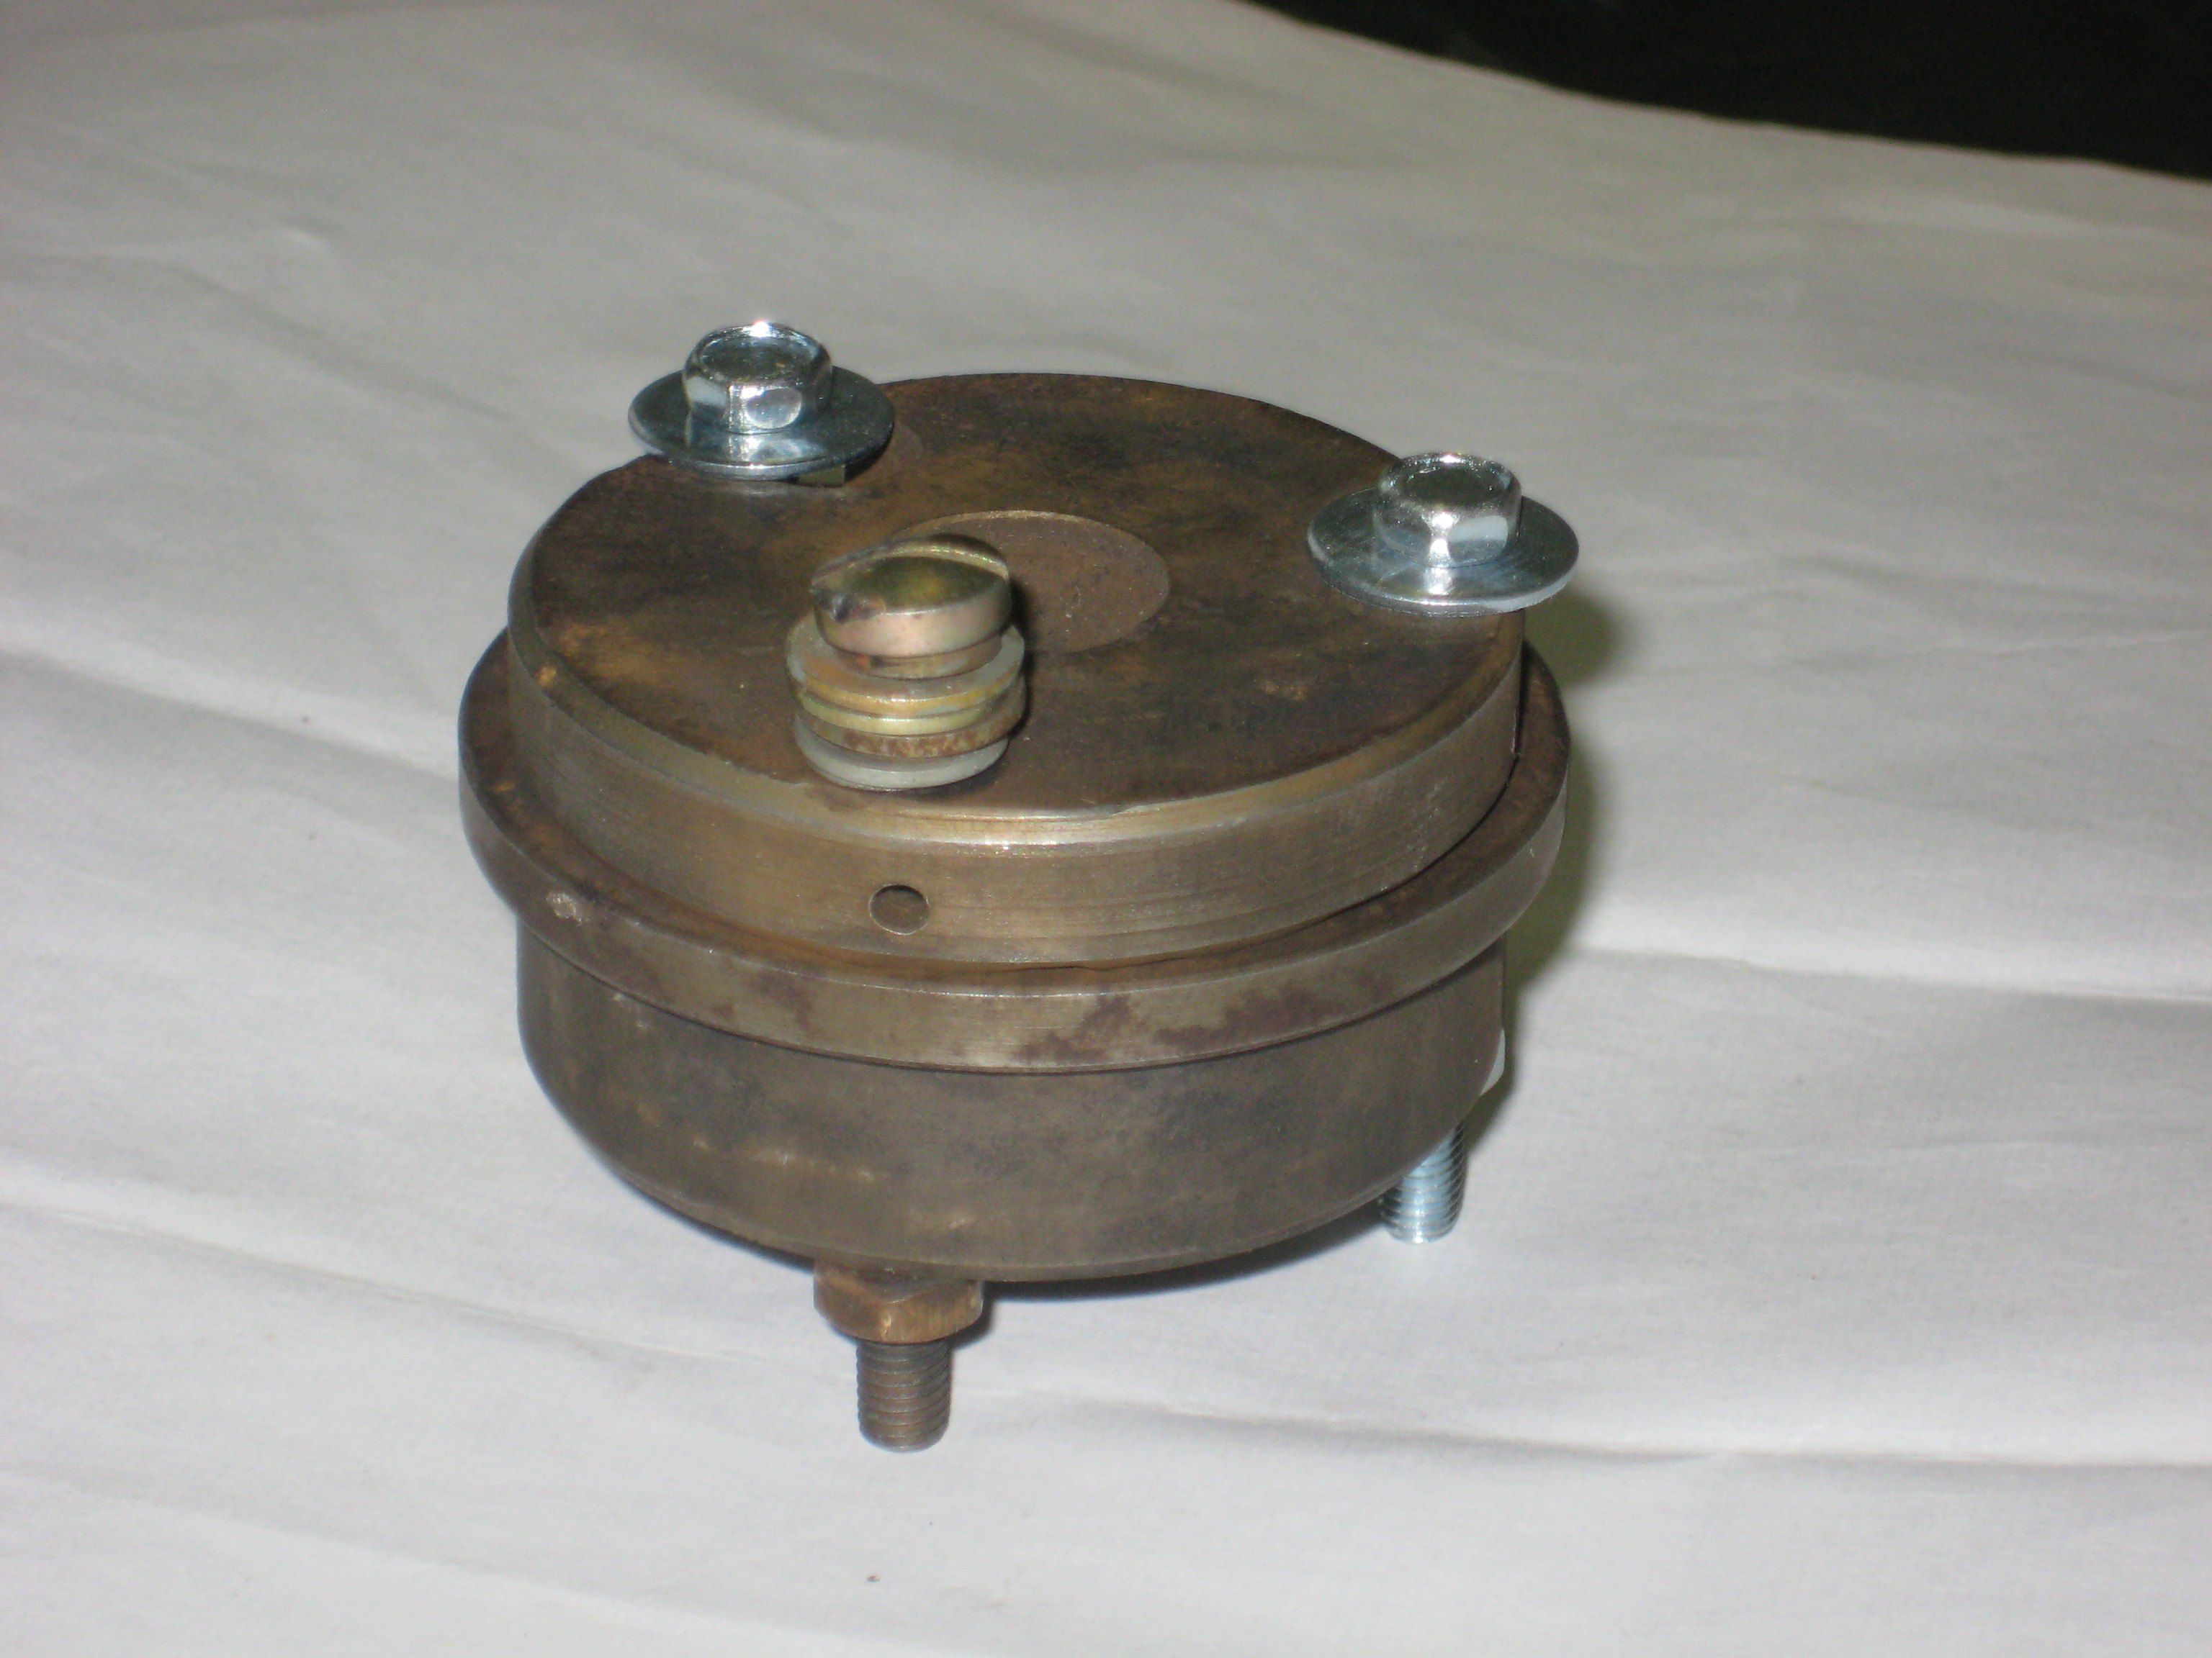

Figure 1. The container with rubber samples inside.

As a shooting substance we use a filler (MMT or WST).
By method of differential scanning calorimetry was established that thermostability of rubber based on isoprene elastomer with MMT is essentially higher at the case of SDP use as compared with mixing in melt (Table 1).

Table 1. The thermostability of rubber based on isoprene elastomer with MMT

The method of preparing | T ⁰C of oxidation | The mass losses,%
SDP | 348 | 28
In melt | 339 | 39

Simultaneously, the conditional tensile strength, tear, hardness elasticity and adhesion to steel cord (Table 2) increase in case of SDP utilization in comparison with traditional method.
By method of X-ray analysis (at difractometer D8 advance) it was estimated (Figure 2), that in rubber samples, filled by SDP method, MMT reflexes at diffractograms are absent. It indicates that the exfoliation of MMT in rubber matrix takes place.
The modification of rubber mixtures by MMT leads to great decrease of ratio of intensivity of the first and the second maximums. This is connected with increase of dispersion of distances distribution between neighboring polymer chains and therefore with penetration of them into interlayer space of MMT

Table 2. The physical-mechanical properties of rubber based on isoprene elastomer (SRI)

The properties | The composition and method of processing
The properties | SRI | SRI+5 mass fr. MMT (in melt) | SRI+5 mass fr. MMT (SDP)
Tensile strength, MPa | 15 | 13 | 22
Tear, kN/m | 43 | 35 | 52
Hardness, arbitrary units | 59 | 71 | 78
Elasticity, % | 52 | 60 | 70
Adhesion to steel cord, N | 9 | 8 | 11

.
1
2
3
Figure 2. Diffractogram of rubber mixtures based on isoprene elastomer (1) and its composition with 1 (2) и 3 (3) mass.fr. MMT

As a nanofiller in isoprene rubber mixtures was used also wollastonite which has the needle-like shape of its particles. The surface of this mineral was organomodified by alkilbenzildimetilammony chloride (Catamine AB).
The structure of rubbers with modified wollastonite was investigated by electron microscopy at the Auriga device of Zeiss company.
The comparison of structure of rubbers, manufactured by SDP and mixing in melt, was shown, that nanofiller particles irregularly distributed in polymer matrix independently of production method. At the same time the greater amount of filler particles with smaller size are formed by use of SDP method as compared to traditional way of component mixing. This naturally increases the surface of phase separation, what positively influences on the complex of physical-mechanical and other properties of rubbers [4].
The maximum of strength and adhesion properties of rubbers are achieved at 3 mass. fr. of described filler content (Figure 3). The rubber mixtures of this composition are characterized by smaller size of filler particles (Figure 4).
Due to greater surface of phase separation the SDP method provides the best properties of rubber with modified wollastonite in comparison to traditional way of nanocomposite production (Table 3). So the tensile strength increases by 15% and adhesion to steel cord approximately by the same degree. The tear increases greater than other properties of rubber with wollastonite.

Figure 3. The concentration dependence of tensile strength and relative elongation of rubber mixtures based on isoprene elastomer.

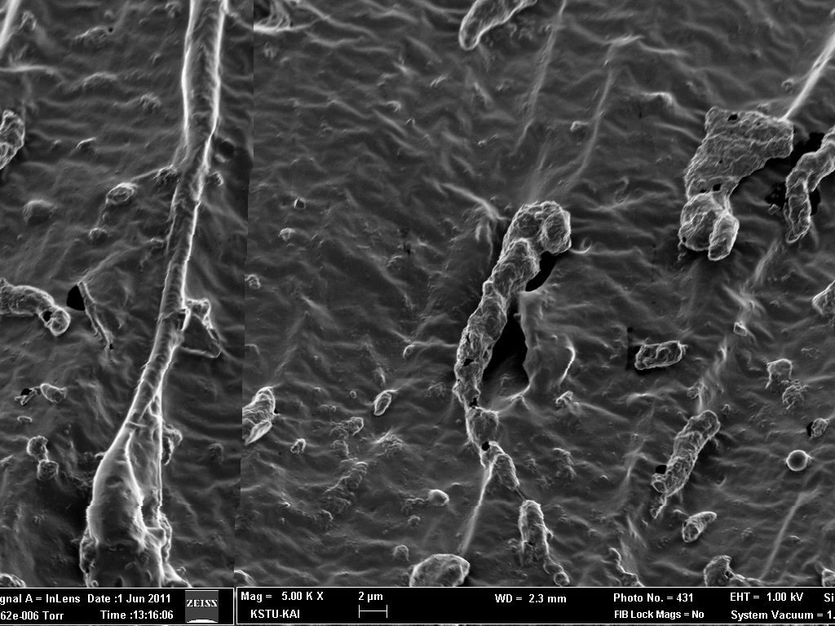 a 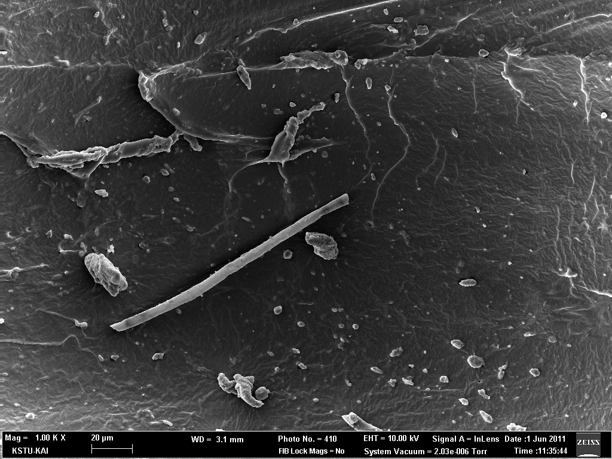 b
Figure 4. The electronic microscope pictures of structure of rubbers based on isoprene elastomer, modified with 3 mass. fr. of wollastone by SDP method (b) and mixing in melt (a)

Table 3. Physical-mechanical and adhesion properties of rubber based on isoprene elastomer.

The properties | The composition and method of processing
The properties | Unfilled ruber | rubber+3 mass fr. WST (SDP) | rubber+3 mass fr. WST (in melt)
Tensile strength, MPa | 15 | 28 | 24
Tear, kN/m | 43 | 53 | 42
Hardness, arbitrary units | 59 | 68 | 61
Elasticity, % | 52 | 53 | 52
Adhesion to steel cord, N | 9 | 15 | 13

It was also important to estimate the influence of modified WST on vulcanization characteristics of rubber mixtures, because them determine the behavior in the processing of nanocompositions. The data of Table 4 demonstrate that the time of vulcanization beginning increases at 1 mass. fr. of WST, and at it’s optimal content - 3 mass. fr. it is at the level of unfilled rubber mixture. The optimal vulcanization time at 1 mass. fr. of WST greatly increases and at 3 mass. fr. – a little decreases.
So, the modified WST does not complicate rubber mixtures processing.
It is important to underline that polar laminated silicates, such as MMT practically don’t increase the physical mechanical properties of nonpolar isoprene rubber at mixing in melt. At the same time the SDP method is more effective for production of nanocomposites based on nonpolar elastomers and polar laminated silicates.

Table 4 . Rheometric characteristics of isoprene rubber mixtures

The composition | Min torque | Max torque | T _{beginning}, min | T _{optimal}, min
Unfilled rubber mixture | 18 | 31 | 1,25 | 9,5
Rubber mixture+1 mass.fr.  of modified WST | 36 | 45 | 0,9 | 13,8
Rubber mixture+3 mass.fr.  of modified WST | 29 | 40 | 1,2 | 8,0

In the case of WST the great amount of anisotropic particles of nanofiller are formed. They play the role of amplifying elements of polymer structure. So we can say that by SDP method reinforcing effect can be obtained at small amounts of disperse filler.

CONCLUSIONS

The SDP method opens the great perspectives for creation advanced nanocomposites based on non polar elastomers and polar nanofillers. This method is more effective than mixing of components of rubber mixtures in melt. The optimization of explosion conditions while using SDP method will provide of further improvement of nanocomposite properties. This new method of mixing nanofillers with polymer matrixes allows to produce smart functional materials based on polymers of different chemical composition and polarity.

REFERENCES

- Figovsky, O. and Usherenko, S. 2009. Composite Materials Prepared by SDP-Method: the Physics of Superdeep Penetration. Nanotechnics, 3(19): 27-37.
- Figovsky O., 2008. The physics of superdeep deep penetration phenomenon. Journal of Technical Physics, 1(49): 3-25.
- Figovsky, O. and Usherenko, S. Superdeep penetration as the new: physical tool for creation of composite materials. 2008. Advanced Materials Research, Vols. 47-50: 395-402.
- Gotlib Е., Figovsky O., Naumov S., Ilicheva E. 2011. Influence of mixing method of modified wollastonite with rubbers based on SRI-3 on their structure. Newsletter of the Kazan State Technological University, 15: 141-145

