DETOXICATION OF PESTICIDE AND OTHER TOXIC SUBSTANCE REMAINS IN SOIL WITH THE HELP OF NANOMATERIALS

Dedicated to the blessed memory of

Prof. Ruban Igor Nikolaevich

O.Figovsky¹ , Y.Spiridinov², V.Muhin³, N.Voropaeva¹, V.Gorsckov⁴, E.Gorsckova⁴, V.Karpachev⁴
¹Polymate Ltd.-INRC, Migdal Ha Emek, Israel
²State Research Institution All-Russian Research Institute of Phytopathology, Moscow region, Russia, Golitsino c.
³«ENPO “NEORGANIKA“» Joint Stock Company, Moscow region, Russia, Electrostal
⁴State Research Institution All-Russian Rapeseed Research Institute (ARRI), Lipetsk, Russia
Abstract: Intensification of agricultural production involves a large – scale use of fertilizers, plant protection means against pests, diseases and weeds, all those are used within various modern agro-technologies, which leads to soil intoxication with residual amounts of pesticides and agrochemicals. Therefore, a comprehensive approach is necessary for preparing the soil for further sowing. We have carried out the research using activated carbons obtained from agricultural residues.
Keywords: detoxication, pesticide, toxic substance,active carbon, nanomaterials, (nano)chips, pre-sowing seed treatment;growth, development, the incidence of plants, the quantity and quality of their crop.
INTRODUCTION
Environmental safety of agricultural sector and quality of food supply are both of great international importance. Constantly growing environmental pollution makes environmental safety an important part of national safety aspect in general. Among the national safety threats connected with environmental pollution, there are threats connected with water reservoir anddrinking water pollution, as there are the threats connected with pesticides' presence in the soil and in products, such threats are the most dangerous threats after radiation pollution and oil spilling. “Today when a matter of life and death is highly acute in view of disastrous biocontamination, it is high time to apply absorption – one of the most efficient methods of environment protection”( MCTI of Mendeleev D. I., Prof. Keltsev H.V.).
Minister of Agriculture of the Russian Federation Nikolai Fyodorov, speaking on February 27, 2014 in Moscow at the opening of the first meeting of the "Group of Eight" of the major world powers, noted the need to "... focus the efforts of the international community on" first principle, the basis of all agricultural production - soil ". On July 24, 2014 the representatives of the various countries and FAO experts endorsed the Global Plan of Action to prevent soil degradation [1]. "The soil is the basis for the production of food, feed, fiber and fuel, - said Deputy Director General Maria Helena Semedo. - Without soil, we cannot sustain life on earth, and in the case of loss of soil resources, they cannot be recovered during the lifetime of one generation.
The current escalation of land degradation threatens the potential of future generations to meet their needs. That is why the adoption of the Global Plan of Action for the sustainable use and soil protection is a huge achievement. But we cannot stop on that point. We need the commitment of countries and the civil society to put these plans into reality. All this requires the political will and investments to save valuable soil resources whichour agroindustrial complexes depend on". The farmland area contaminated by pesticide residues is above the established norms, only in Russia this index makes up more than 50 million. ha. Their return into the rotation process to obtain clean crop production is one of the most important tasks of our time. The development of agricultural technologies aimed at the rehabilitation of anthropogenically destroyed areas is one way to resolve the situation
RESULTS AND DISCUSSION
Soil quality is the main aspect in agricultural production; the soil is exposed to great stress as a result of intensive pesticide usage. It is widely known that to remove pesticide, xenobiotic or other toxic substance residual quantity from the soil, various sorbate – detoxicants of natural and unnatural origin [1-9]. This problem becomes even more urgent today, when ecological crisis is deepening, the need in nature conservation technology is also becoming greater . Application of active carbons (AC) as high-quality sorbents , and inactive high-porous matrix carriers of active components is of particular interest for resolving the problems of agro-industrial sector. It is to be noted, that to resolve the problems connected with the environment, more than 10% of activated carbon materials are used, such materials are produced by manufacturers all over the whole world [10]. In Table 1there are internationally important technologies of active carbon application for biosphere “ecologization”. Besides, one should mention new threats rising all the time, to deal with which AC is needed.
Owing to their physicochemical properties carbon absorbents (active carbons) are unique and ideal adsorption materials, which allow of resolving various problems connected with chemical and biological safety of humans, environment and infrastructure [10-42]. Active carbon are high-porous carbon materials with highly developed internal structure (1000-2000 m²\g). This property is the result of high internal porosity, which includes macro-, meso- and micropores. Such porous structure of active carbon (micro- and mesospore size) absorbs all kinds of organic trace contaminants due to its adsorptive capacity (surface interaction processes). Microspores of carbon absorbents have slit-like form and are expressed as their half-width – x. To micropores we refer pores of x<0,6-0,7 nm, and also some bigger pores (0,6-0,7 < х < 1,5-1,6 нм), called supermicropores. Exactly in these pores the admixture absorption takes place due to Van der Waals' forces and their non-specific interactions. It means carbon absorbents are standard nanomaterials. Certain microspore nano-structure formation is a process taking place during active carbon obtainment through application of some specific raw material and certain thermal treatment regimes (drying, carbonization and activation). The macropores and mesopores of active carbons and carbon absorbent act as transport links and influence on process kinetics. Macropores possess an effective radius (r_{ef}) of more than 100-200 nm, but their surface makes only 0,5-2,0 m ²\g.
Table 1.Technologies of active carbon application for biosphere “ecologization”.
Part biosphere | Carbon absorption technology
Atmosphere | Solution recuperation  Sanitary end gas purification , including desulfurization  Nuclear power plant gas purification system  Recovery of transport fuel gas  Chemical weapon elimination  Solid domestic and sanitary waste elimination  Cleaning of the air in living and working space (air conditioning)
Hydrosphere | Drinking water purification  Water-borne wastessterilization  Liquid radioactive waste treatment  Gold nonferrous materials mining
Lithosphere | Soil protection from xenobiotics, including pesticides  Soil resuscitation  Sanitary control of water sources zones
Human | Individual and collective protection means of filter type/  Chemical pharm. , vitamins, antibiotic production  Enterosorption and hemosorption  Environmentally safe products manufacturing
Mesopores (transitional pores) have efficient radius from 1,5-1,6 to 100-200 nm and their specific surface is 50-100 m ²\g, some certain samples have the surface of 300-400 m ²\g. The parameters of carbon active porous structure are shown in Table 2.
In various literature sources, for example, one can find vegetation and field test results of active carbon application as efficient means of soil fertility restoration, lost due to soil exhaustion and soil contamination with residual chlorosulfon and other herbicides [2-4]. By studying kinetics of chlorosulfon extraction from a solution with the help of active carbon, S.I. Shmelev and et al. [5] showed that in three days within the etalon experiment 95% of chlorosulfon turned into the absorbed state of AC. In this work [6] active carbon application for tomato and houndsberry protection against metribuzin herbicide and its mixtures with napropamide is studied.

Table 2. Porous structure of active carbons
Poretype | Porevolume sm³ \ g | Poresize, nm | Poresurface, m²\g
Macropores | 0,2-0,6 | Poreradius>100-200 | 0,5-2,0
Mesopores (transition pores) | 0,1-0,4 | Pore radius 1,5-1,6 – 100-200 | 50-200
Micropores:
Micropores proper | 0.3 – 0.7 | slit half-width size < 0,6-0,7 | 1200 - 1500
Super micropores | 0,1 – 0,3 | slit half-width size | 500- 800
Total pore volume | 0,7 – 2,0 | 0,6-0,7 – 0,5 – 1,6 | 1800-2000
* Notes: the indices have been taken from the book “Activated carbon. “Flexible sorbates, catalysts, dehydrators and chemical absorbers based on them ”. Nomenclatural index. Ed. D.Ph. V. M. Muhin. – M.: Publishing house “Ore and metals”, 2003. – 278 p.
As raw materials to obtain active carbon one can use coal, peat, timber, shell, various plant residues and other cheap materials.
For resolving environmental problems of the agricultural sector such active carbons have certain advantages, for instance, selectivity of organic toxin absorption, absorption properties universality, high absorptive capacity, hydrophobicity, they are also suitable for preparations (powder, granules), and more than that their price is low (0,8-1,5 $US per kilo).
Below there are the results of various vegetation methods application, greenhouse and field tests, these data have been obtained from the study of carbon adsorption and soil detoxication, when the soil was contaminated with various herbicides. In particular, the results of vegetation tests on the podzolic soils near Moscow are shown in Table 3and foto 1-3.

Table 3. The efficiency of soil fertility restoration, when the soils are contaminated with herbicide residues and modified active carbon (application dose – 100 kg\ha).
Herbicide | Herbicide residues in soil, g\ha | Culture | Preserved yield data, culture tests, % the to contaminated level
Chlorosulfon (CSF) | 0,2 | cucumber | 16-20
Chlorosulfon (CSF) | 0,2 | beet | 58-63
Chlorosulfon (CSF) | 0,2 | garden radish | 23-28
Terbisil | 1,4 | cucumber | 23-27
Terbisil | 1,4 | beet | 64-69
Terbisil | 1,4 | garden radish | 30-39
Pikloram | 2 | cucumber | 22-24
Simasin | 50 | tomato | 22-26
Chlorosulfon | 0,4 | tomato | 98-100
Chlorosulfon | 0,4 | beet | 98-99
Chlorosulfon | 0,4 | garden radish | 98-100

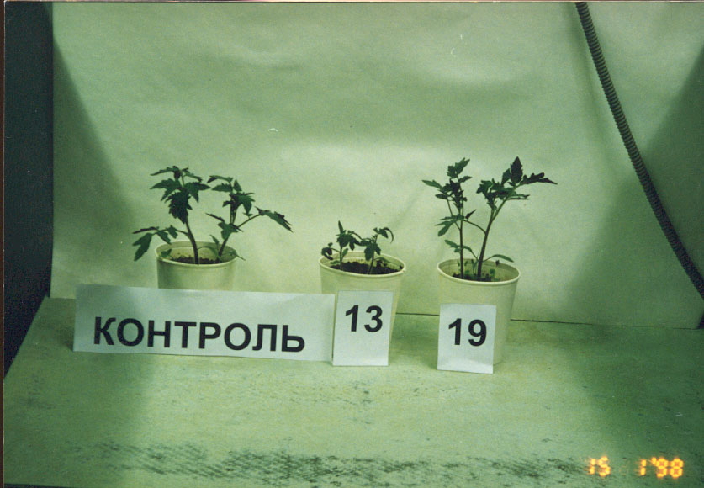
Photo 1.
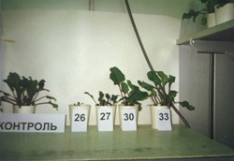
Photo 2.
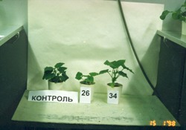
Photo 3.
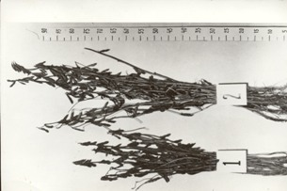
Photo 4.

In Table 4 the results of field tests in Krasnodar chernozem have been shown. In both cases (according to the data from Tables 3,4) the unique effect of herbicide residues “elimination” in various sowing tests is obvious.
One should especially note that, in the tests with various agricultural crops cultivated (beetroot, garden radish, cucumber, tomato) in the soils which were not contaminated with herbicides, a positive influence of carbon absorbents on the tested crops has been detected.
Table 5 shows the influence of various absorbent brands and doses on table beet growth according to the vegetation test conducted All-Russian Research Institute of Phytopathology (Golitsyno c. Moscow region).
Test crops mass increase by 10-15 % along with active carbon dose increase from 100 to 400 kg\ha can probably be explained by certain endogenous phytotoxins, typical for this crop, accumulating in the soil during the natural process of soil exhaustion and then connecting to the absorbent.
Table 4 Agricultural crop yield against the background of herbicides and active carbon (AC) application at doses 50 kg\ha.

Crop | Herbicide and dose background, kg\ha | Yield against the background of herbicides, c\ha | Yield after AC application | Yield increase, c\ha (%)
Corn (per grain) | Treflan 1,4 | 53 | 78 | 25(47)
Tomatoes | Treflan 1,5 | 333 | 652 | 319(96)
Sugar beet | Treflan 1,5 | 343 | 416 | 73 (21)
Rice | Ronstar 2,0 | 60 | 72 | 12 (20)
Bulb onion | Ramrod 8,5 | 228 | 295 | 67 (29)
Cucumber | Treflan 1,0 | 85 | 202 | 117(138)
Soya | Dialen 9,0 | 11 | 24 | 13(118)
Winter wheat* | Unidentified residues | 43 | 49 | 6(14)
Corn* (green Mass) | Unidentified residues | 342 | 592 | 250(73)
Rice | Unidentified residues | 63 | 85 | 22 (35)
*-active carbon dose 100 kg\ha
The results of comparative research works conducted on the range of agricultural crops being cultivated in the soils contaminated with herbicides like treflan (1 kg \ ha) and 2,4 D (2,4- dichlorophenoxyacetic acid) (5-10 kg\ha), in accordance with the conventional cultivating technology using carbon adsorbents, have shown that introducing the absorbent into the contaminated soils in the amount up to 100 kg \ ha (in case with barley crop this amount was up to 200 kg \ ha) can allow of reducing (or sometimes even prevent ) herbicide accumulation in plant and vegetable products [7] .
Table 5. Table beet growth depending on various absorbent brands with the soil contaminated
Contaminating substance dose – HSF, kg\ha | Plant green mass, in % to the control variant
Contaminating substance dose – HSF, kg\ha | UMD –1 | UMD –2 | UMD –3
Adsorbent norm 0 kg\ha
0,1 | 3 | 9 | 16
0,2 | 2 | 2 | 6
Adsorbent norm 100 kg\ha
0,1 | 12 | g 46 | g 25
0,2 | 8 | 27 | 16
0 | 102 | 105 | 134
Adsorbent norm 200 kg\ha
0,1 | 25 | 100 | 34
0,2 | 21 | 92 | 20
0 | 105 | 111 | 201
Adsorbent norm 400 kg\ha
0,1 | 40 | 93 | 145
0,2 | 37 | 101 | 124
0 | 107 | 116 | 210

*-UMD –1 - powder form (active carbon + natural clinoptilolite ), UMD –2 - powder form (active carbon + synthetic zeolite, UMD –3- grained form (active carbon + natural clinoptilolite); in all the absorbent compositions the masses are the same.
The same results have been obtained from corn cultivation in the soils contaminated with herbicide atrazin (Table 7).
Thus, the application of active carbon for soil detoxication by fixation herbicide residues have two main aspects: yield increase in contaminated soils by 20-80% and an opportunity to obtain yields brought up to the “dietary” mark.

Table 6.Herbicide content in agricultural products.

Herbicide and its dose, kg\ha | Active carbon dose, kg \ ha | Test - crop | Herbicide content in products, mkg \ kg
Treflan - 1 | - | Tomatoes | 28
Treflan - 1 | 100 | Tomatoes | 0,6
Treflan - 1 | - | Carrot | 95
Treflan - 1 | 100 | Carrot | Not detected
2.4 – D - 5 | - | Barley | 220
2.4 – D - 5 | 200 | Barley | Not detected
2.4 – D - U | - | Barley | 670
2.4 – D - U | 200 | Barley | Not detected

Table 7.Atrazin accumulation in corn

Active carbon dose, kg\ha | Atrazincontent, mkg \ kg
Active carbon dose, kg\ha | In green mass to ensilage at doses of atrazin, kg\ha |  |  | In grain forms at doses of atrazin, kg \ ha
Active carbon dose, kg\ha | 8 | 16 | 32 | 8 | 16 | 32
0 | 2 | 5 | 13 | 7 | 11 | 29
50 | Not detected | Not detected | 1 | Not detected | 1 | 2
100 | Not detected | Not detected | Not detected | Not detected | Not detected | Not detected

Both effects are conditional on pesticide absorption in the soils containing active carbon, that means fixating pesticides within the structure of active carbon, thus making them unable to penetrate plants and their root system, it also prevents them from further spreading in the soil. Thus, the negative effect of these toxins on crop yield is being reduced.
Besides, it has been noted that the xenobiotics absorbed by active carbons are also unavailable for destructive soil microorganisms, and also only after desorption of this type of contaminating substances into the aqueous phase, they start being influenced by microflora. However, this process is quite energetically costly (time-consuming also), that it will take the soil 3-4 years for natural purification. One should note that active carbon by itself does not affect plant life and soil biota activity. The safety of these components is proved by the fact that they are used as efficient absorbents of various toxins of exo - and endogenous origin in medicine and veterinary for human and animal treatment without any restrictions.

Table 8.
Herbicide detoxication and crop development levels when using active carbon at doses 100 kg\ha

Crop, herbicide and the dose g\ha | Herbicide content decrease in soil, % | Green mass increase, %
Garden radish, Chlorsulfuron, 0,2 | 40-45 | 23-28
Cucumber, Picloram, 2 | 33-37 | 22-24
Tomato, Simazin, 50 | 34-40 | 22-26

These data are also supported by the results, obtained in Krasnodar All-Russian research institute of biological plant protection by Belousov V. C. and Shmelev V.I. [5], who studied chlorsulfuron extraction kinetics with the help of active carbon CKT (Fig. 1).
Thus, the mechanism of herbicide fixation consists in herbicide absorption by active carbons. As it is obvious from the kinetic curve (Fig. 1), within tree days chlorsulforon almost disappears from aqueous phase and becomes and absorbed substance.

C, micromole \l
Time, h.

Fig. 1. Kinetic curve of chlorsulfuron absorption from aqueous solution by active carbon of CKT brand

A remarkable example, proving these results, has been shown in the report of O. Kovaleva et al. on the 2 International conference of Chemiscal Society of the Republic of Moldova [9]. Studying the method of biological degradation of benzotiazole in the soil, which is formed as a result of tyre rubber interacting with asphalt roads, benzotiazole is a very strong carcinogen, these authors used 76 bacteria varieties from microbe bank of Moldova , two of them decomposed the xenobiotic successfully. In the soil there are 10 times more bacteria and fungi than in any research bank, so it means there is always a destructor of this or that pesticide.
In case of specific strain- destructors, introduced on active carbons, carbon pores protect them in the aggressive natural soil bio flora, allowing them to grow and breed, feeding on pesticide, absorbed from the soil. In this case, purification increasing effect exhibits a synergistic behavior.
Besides, the destruction of pesticides on the surface of active carbons, may, probably, take place, due to the oxidation, where oxygencontaining groups take their part, to the catalysis in certain active points, physicochemical influence of absorption potential of micropores and the other mechanisms.
The efficiency of active carbons application in agricultural technologies is defined not only by its type (raw material type, absorbing pore size, transport and absorbing pore correlation), but also by application methods (grains and suspension, overall application, application in patches or in certain areas of seed sowing, embedding depth and other factors).
The newest approach in this area is a sorption-biological soil remediation, developed by “Neorganika” company together with Institute of Physicochemical and Biological Problems of Soil Science, RAS (Pushino t.). this approach is connected with soil cleaning method, based on using small doses of absorbent ( 1-5% of soil mass), which is put into the soil together with specifically grown microbe strains - pesticide destructors.
On the figure 2, for instance, the results of propanid pesticide destruction tests are shown, where the pesticide got in the soil as a result of the car accident with a truck-mounted tanker having taken place in Krasnodar region. This method, apparently, can be adapted to soil cleaning, where the soil are contaminated with various organic chemicals, petrochemical and other poisonous products.
With the average rate of active carbon application, the active carbon brand AG 25-100 kg\ha, the expected economic growth, caused by various crop yield increase, can be amounted to 550-1800 US$ from one hectare. Thus, only on Moscow soils (including flood and greenhouse lands) are estimated at 70 US$.
Some certain soil detoxication aspect is connected to defoliant-substance application, causing leaf exfoliation. These substances, used during cotton harvest, were used by US army in Vietnam to destroy tree leaves to find out the enemy dislocation. In nature these substances transform into dioxins – extra poisonous substances for humans.
The preliminary experiments, conducted by All-Russian Research Institute of phytopathology, have shown that adding active carbons to the soil, contaminated with such xenobiotics, leads to these absorbents extraction from the soil and fixating them in the porous structure. As a result, the negative influence of xenobiotics on the lithosphere and hydrosphere is reduced.
The research works conducted nowadays are aimed at active carbon obtainment from various agricultural crop residues (straw of oil and grain crops) and their further application as a promising annually renewable source for sorbate development and, thus, for, agricultural soils improvement.
To define the properties of the active carbons obtained during the research works, we used State Standards and methods, along with the surface area and solid material porosity analysis device ASAP 2020 [11-22].

Propanid in natural conditions,
propanid bio destruction, dichloraniline, mg\kg

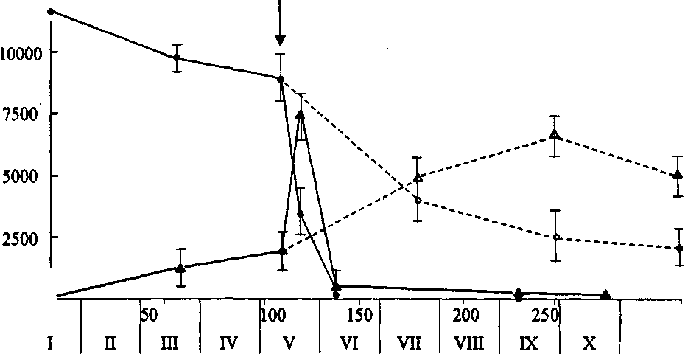

days \ months
Figure 2.The dynamics of propanid concentration changes (1 and 2) and DCHA (3 and 4) in the soil on the site of the accident.(Solid line – observed, dashed line – the soil without treatment, the arrow shows the beginning of the works aimed at accident consequences elimination by adding active carbons (50 kg\ha) and MFDD (microorganisms for dichloraniline destruction) (10⁵ cells\ g) into the soil)

The sorbates obtained by rape, barley , wheat and straw processing into active carbons according to the method [11,12] (product yield amounts from 8,4%- 16,0%) have total pore volume from 3,53 cm ³\g to 4,14 cm ³\g, ultimate sorptive volume from 0,28 to 0,73 cm ³\g, micropore sizes of 0,6 – 1,0 nm, sorptive power according to iodine from 39,0% to 43,0%, according to methylene blue – from 37,0 mg/g to 87,0 mg\g, which allows of using them for soil detoxication from pesticide residues, because they meet the requirements, especially set to sorbates for “soil” improvement [22]. Agricultural sorbates have to hold on pesticide molecules and their destruction products. Besides, transport porosity of agricultural sorbates should be well developed to provide the necessary absorption speed.
The researches that we conducted, taking sunflower crop as the example, according to the method [2] have shown the rapid decrease of metsulfuron-methyl herbicide phytotoxic activity (Singer S.P.) from 73,2% to 4,9% when using agro sorbates based on active carbons from rape, barley and wheat crops, during the sowing period ( this index of carbons Swiss Norit company, Grosafe brand, as the result of using active carbons, amounted to 12,2%, and AC from antriatsit –51,2%). The average mass of the sunflower plants cultivated (in vegetation tests) changed from 1,1 g, when herbicide Singer had been put into the soil, to 3,9 g, when the active carbons, made of wheat and barley straw, had been put into the soil together with the herbicide (in the control variant this index amounts to 4,3 g (photo 5), which proofs of a quite high detoxication activity of the sorbates, obtained from plant residues of grain crops.
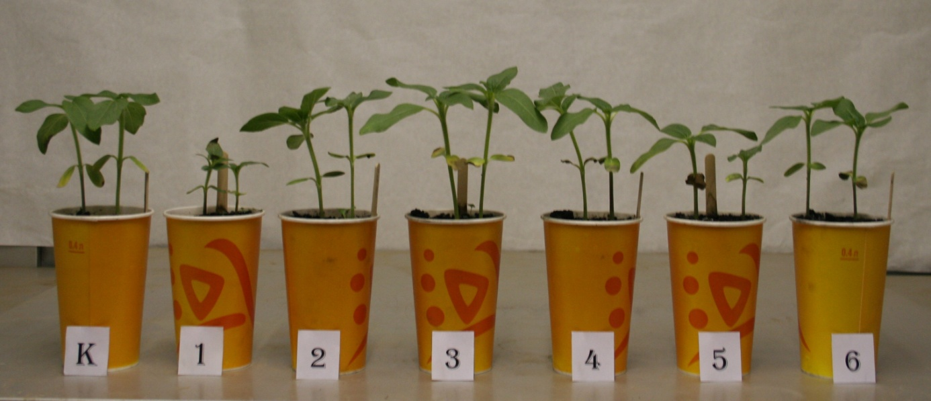
Photo 5. K-control, 1-Zinger, SP, 2-AC from barley straw, 3 – AC of wheat straw, 4 – AC of rape straw, 5 – AC of antriatsit, 6 – AC of Grosafe brand (Switzerland).

Conducting researchworks on detoxification of soil with the sorbents of diverse nature, including active carbons obtained by processing the straw of different crops (brassica oilseeds, cereals and others) before sowing breeding samples of different cultures to optimize the selection process is currently very accute approach because the rest residual amounts of pesticides (herbicides, insecticide, fungicide, bactericide, and other plant protection chemicals) in the soil have an inhibitory effect on the productivity of many species of plants, thereby they significantly distort the results. In breeding practice there has always existed the problem of increasing the objectivity of the field evaluation of selection samples (lines, accessions) by leveling diversity of soil fertility. Therefore, a comprehensive approach to the preparation of soil and seeds for sowing, and that forms the basis of the research data on the leveling of the harmful effects of various toxicants in the process of breeding.
Taking into the consideration that the active carbons have no adverse effects on plant life and activity of soil biota, as evidenced by numerous studies, and the fact that many preparations containing such carbons are used as sorbentsin medical and veterinary practice for the treatment of humans and animals, effectively linking various toxins of exogenous and endogenous origin, the research works were conducted to study the effect ofcarbon - adsorbtion detoxification of soil on growth, development of rape plants in the process of selection. For this, two approacheswere used: the first is to introduce active carbons and similar carbon adsorbents into the soil in certain dosestogether with the seeds (if sowing) using agricultural machinery,followed by their introductioninto the predetermined depth, as described above in the cultivation of various crops; and the second isto apply them to the seed surface consisting of (nano) chips for the treatment of seeds according to the patent [43]. The selection of specific ways of introducing these materials into the soil within this method is carried out taking into account the toxicological indicators of soil and agro-climatic features of the studied areas.
The increase in weight and length of rape sprouts in field trials in the initial period of development of the different varieties of this crop (Ratnik, Bulat, Forward, Reef, Altair) by 11,0-19,0%, contributing to the increase of yield up to 10,8%, was due to, probably, the bondage of carbonaceous adsorbents of "some" endogenous stufftypical only to the given culture of phytotoxicants accumulating in soils under natural soil exhaustion , and fixing the residual amounts of herbicides, pesticides and other xenobiotics especially dangerous, allowing, in the end, to slightly "smooth" the diversity of soil fertility and getting in the future environmentally friendly or safe products.

CONCLUSION
Thus, an opportunity of efficient agricultural soils detoxication has been detected, with the crops treated with herbicides together with the active carbons, obtained from grain crop straw, as annually renewable natural source. Soil protection from various pesticides will become even more urgent in the near future, because of the constantly growing world population and low artificial food development tempos. That is why fertile soil protection, which is only 6% of the total land area, is becoming urgent in the XXI century. One should note the importance of agricultural land protection in Russia, which has 38% of world chernozem – the most fertile soils for agricultural cultivation. Precisely soil detoxication technology with the help of active carbons will allow of yield increase in the areas of intensive cultivation (China, South-Eastern Asia, Middle East, African oases), but also will facilitate the essential improvement of the quality of agricultural products and, as a result, will lead to healthier nations.
The work has been performed as a part of R&D task to "Develop an environmentally safe (nano) technology of pre-sowingseed treatment of brassica crops using (nano) chip-based biopesticides"; "Create a new oilseed varieties of cabbage crops, combining high productivity with resistance to major pathogens, pests, abiotic stressors , technological in production" and the assignment № 16.711.2014/ K to perform a research under the project of the state task to the educational organizations and higher education scientific organizations under RF Ministry of Education and Science. The Translation mate by Simtsova E.S.
Благодарности.
Коллектив авторов выражает благодарность фондам за поддержку проводимых исследований и переводчику Е. Симцовой за высокий профессионализм в работе.

REFERENCES
- Food and Agriculture Organization of the United Nations/ URL: www.fao.org/news/story/ru/item/239702/icode/.
- U.Y. Spiridonov, V. M. Muhin, V.G. Shestakov. Environmentally clean method of soil sanitation from pesticides and exhaustion -Agrochemistry. – 1998. - N 11. - P. 70-75.
- N. A. Zimin, V. M. Muhin, U.Y. Spiridonov, A.A. Hazanov, A.N. Tamamian, V. G. Shestakov. Active carbon obtainment method for agricultural crops protection from pesticide residues in the soil. \\ RF Patent 2167102.
- V. M. Muhin, U.Y. Spiridonov, V. G. Shestakov. Soil fertilization restoration method\\ RF Patent 2140339.
- S. I. Shmelev, G. P, Zikova, V. C. Belousov. The destruction of chlorsulfuron, adsorbed by active carbon (AC)\ \\ All-Russian research symposium materials The control of soil contamination with xenobiotics and adsorption methods of detoxication. –Krasnodar. -1993. –P.99.
- J. Toth. Use of activated carbon to protect tomato against metribuzin / J. Toth, P.J. Milham, G.R. Hillier, C.J. Kaldor // Weed Res. – 1987. - Т. 27.-N 5. - P. 367-373.
- A. Krauze. Uszkodzenia nerbicydowe roslin uprawnych /A. Krauze // Ochr. Rosl. - 1986. - Т. 30. - N 11/12. -S. 14-16.
- J. Masiunas. Weed control in vtne crops: can weeds be controlled /J. Masiunas, R. Lindstrom // Horticulture ser. – 1988. - Т. 72. - P. 101-103.
- O. Covaliova, Researches on the benzothiazole destruction phenomena occuring in different photo- biocatalytic system / O. Covaliova, A. Bunescu, I. Dragalin. and oth. // The IInd Intenational Conference of the Chemical Society of the Republic of Moldova “Achievements and Perspectives of Modern Chemistry”. -2007. – P. 149.
- E. Y. Belyaev. Obtainment and application of wood active carbons from environmental purposes. E. Y. Belyaev. Plant raw material.- 2000. -№2. -P. 5–15.
- Active carbons. Elastic sorbents, catalysts, dehydrators and chemical absorbents based on them. High-ranking catalogue. Ed. By PhD. V. M. Muhin. – M.: Publishing house “Оre and metals” 2003. – 278 p.
- V. M. Muhin, V. N. Klushin. Production and application of carbon absorbents.-M.: RchTU of Mendeleev D. I. -2012. – 308 с.
- State Standard 12596-67. Active Carbons.Ash mass fraction determination method.
- State Standard 16188-70. Sorbates.Firmness determination method.
- State Standard 16190-70. Sorbates.Apparent density determination method.
- State Standard 17219-71. Total water pore volume determination method.
- State Standard 16187-70. Sorbates.Fractional composition determination method.
- State Standard 12597-67. Sorbates.Determination method of mass fraction of water in active carbons and catalyst based on them.
- State Standard 6217-74. Crushed active wood carbon. Technical requirements
- State Standard 6382-2001. Volatile matter content determination method.
- State Standard 17218-71. Protection activity period determination method by benzol.
- State Standard 6-16-28-1652-2002. Efficient micropore volume determination method.
- V.M. Muhin. Active carbon role for resolving environmental problems of agricultural sector. U.Y. Spiridonov.\\ Materials collection from All-Russian conference, with the international members invited, on fundamental questions of absorption. – 2013. – Tver, Russia.- С. 34-35.
- I.N.Ruban, N.L.Voropaeva, V.M.Mukhin, Y.Y.Spiridonov, V.V.Karpachev, O.L.Figovsky. Crop residues as a promising resource for the formation of carbon nanostructures.Proc. Collection of abstracts of the fifth annual conference of Nanotechnology Russian society.Moscow, NOR, 2013. P.11-12. http: //www.rusnor. org / upload / My / 2013 / konf / doclad.pdf; http: // www.rusnor.org.
- Yu.Spiridonov Mukhin V.M., Voropaeva N.L.,Pshenichnikova N.L., V.V.Karpachev Detoxification of soil from pesticide residues and other toxic substances with active carbons obtained from plant waste. Proc. Proceedings of the International Scientific and Practical Internet Conference "Modern technologies of cultivation of cereals, legumes and industrial crops", dedicated to the 140th anniversary of education SHEI "Kherson State Agrarian University" Kherson, Ukraine, 2014. S.269-273. http: // www.ksau.kherson.ua.
- Mukhin V.M., Karpachev V.V.,Kharlamov S.A., Voropaeva N.L. and others. RF Patent 2527221. A method for producing activated carbon from plant waste. // It is registered in the State Register of Inventions of the Russian Federation 07.07.2014.
- V. Mukhin, N. Voropaeva, V. Karpachev, O.Figovsky. Plant residues of various agricultural crops as renewable raw material for obtaining activated carbon, J.Scientific Israel- Technological Advantages (ISSN-1565-1533),- vоl. 16, no. 2, 2014, -р. 186-189.
- E.M.Pshenichnikova, V.M.Mukhin, N.L.Voropaeva, V.V.Karpachev. Cleaning soil from residual amounts of pesticides and other toxic substances.In the book“Proceedings of the International scientific-practical conference of young scientists and specialists dedicated to A.G.Doyarenko "Perspective directions of research in changing climatic conditions." Saratov, 2014. -C. 416-420.
- V.M.Muhin, N.L.Voropaeva, Y.Y.Spiridonov, V.V.Gur'yanov, S.G.Kireev, A.A.Kurilkin. Active carbons from straw crops and promising area of application. In the book Materials of Russian conference with international participation "Actual problems of the theory of adsorption, porosity and adsorption selectivity” and the international symposium of the 7th Framework Programme Marie Curie Actions «Ecological use of nanosorbents based on natural and synthetic ions and coal" (project ECONANOSORB PIRSES-GA-2011 -295,260) and the school-seminar of young scientists "Synthesis, research and application of adsorbents", 2014, Moscow - Kliazma. - p.36.
- Mukhin V.M., Voropaeva N.L., E.K.Gorshkova, V.V.Karpachev. Physico-chemical and adsorption properties of activated carbons from straw of different crops. Proc. Proceedings of the All-Russian conference with international participation, dedicated to the 110th anniversary of T.G.Plachenova "Actual problems of synthesis of nanoporous materials, surface chemistry and adsorption".- 2014, St. Petersburg, - p.68.
- N.L.Voropaeva, V.M.Muhin, E.K.Gorshkova, V.V.Karpachev. Vegetable waste as a source of new functional materials for various applications. In book Collection of materials of the 10th International scientific-practical conference "recycling, waste treatment and clean technology." Moscow. - 2014,-p.31-35.
- Karpachev V.V., Gorshkov V.V., Voropaeva N.L. Active carbons as detoxicants of soil during the breeding process. In book Materials of International Scientific and Practical Internet Conference "Problems and prospects of development of modern agricultural science", Nikolaev, 2014. - Ukraine, Mykolaiv GSKHOS, - p.79.
- Mukhin V.M., Voropaeva N.L., Gorshkov E.K. Active carbons on the basis of processionof the straw of different crops and their use in agriculture. Proc. Proceedings of the International Scientific and Practical Internet Conference "Problems and prospects of development of modern agricultural science", Nikolaev, -2014, Ukraine, Mykolaiv GSKHOS. - p.80.
- N. Voropaeva, V.Mukhin, Gorshkov V.M., Muravlev A.A., O.Figovsky, V. Karpachev. Plant residues of agricultural crops as a promising source for functional nanomaterial obtainment.In the book«Abstracts of Communication «The International Conference dedicated to the 55th anniversary from the foundation of the Institute of the Academy of Sciences of Moldova», Moldova, Chisinau, -2014 . -р.189.
- V. Mukhin, T. Lupascu, N. Voropaeva, Y. Spiridonov, N. Bogdanovich, V. Gurjanov.. Activated carbons from vegetal raw materials to solve environmental problems.//Chemistry Journal of Moldova.General, Industrial and Ecological Chemistry. -2014, -V.9, -N 1, -р.1-4.
- Mukhin V.M., Voropaeva N.L., Belonozhkina T.G., Karpachev V.V. Active carbons from vegetable waste. Proc. Proceedings of the Regional Conference on the problems of the natural sciences.Lipetsk, -2014.-p.43-46.
- N.L.Voropaeva, V.M. Muhin, V.V. Karpachev. Renewable raw vegetable waste as one of the possible alternatives for active carbons of different purposes.Proc. Proceedings of the 9th International Scientific and Technical Conference "Energy supply and energy conservation in agriculture", Moscow, -2014. -P. 354-360.
- Voropaeva N.L., Mukhin V.M., Scherbatyh I., Gorshkov E.K., Karpachev V.V. Carbonaceous sorbents for different purposes on the basis of the processed plant wastes (straw crops) as a factor in the quality of the APC. In the book “Materials of Russian scientific conference with international participation "Sorption and ion exchange processes in nano- and supramolecular chemistry", Belgorod, -2014. -P.130-134.
- Mukhin V.M, Voropaeva N.L., Spiridonov Y.Y., Bogdanovich N.I.Gur'yanov V.V. Preparation of activated carbons from vegetable raw materials and the study of their adsorption properties. Proc. Proceedings of the Scientific Conference with international participation "Sorption and ion exchange processes in nano- and supramolecular chemistry", Belgorod, 2014. -S.77-83.
- A.I.Konovalov, V.M.Muhin, N.L.Voropaeva, T.G.Belonozhkina, V.V.Karpachev. Innovative technology for processing agricultural residueswith active carbons for different purposes.Proc. Collection of scientific works, SRI SRIIZHK. Proceedings of the III –d International Conference "Innovative development of young scientists - the development of agro-industrial complex" .- v.2, - issue 7. Stavropol. -2014., P. 528-531. www.elibrary.ru, Database International System for Agricultural Science and Technology (AGRIS) .http: //agris.fao.org/.
- L.N.Sibirnaya, V.M.Muhin, V.I.Gorshkov, N.L.Voropaeva, V.V.Karpachev. Active carbons from agricultural waste as detoxicants soil during breeding. Proc. Collection of scientific works.GNU SNIIZHK.Proceedings of the III International Conference "Innovative development of young scientists - the development of agro-industrial complex." - Volume 2, No. 7. 2014.- Stavropol., P. 551-554. www.elibrary.ru, Database International System for Agricultural Science and Technology (AGRIS) .http: //agris.fao.org/.
- Mukhin V.M, Karpachev V.V., Voropaeva N.L. Rape straw as raw material to produce activated carbons. Grassland. -2014, N 1, pp. 41-44.
- Ruban, N. Voropaeva et.al. Biologically active multifunctional nanochips and method application thereof for production of high-quality seed // Patent USA №12459518. – 2012.

