Possible pathway to discovery of superconductivity above 200K

Vadim A. Volochaev
Southern Federal University, Rostov-on-Don, Russian Federation.
Abstract. Based on crystal chemistry analysis and electron-density calculations, author is suggesting the concept of influence of protons on superconductivity and indicating the ideas for determination of superconducting materials with Tc≥200K. The directions for further research in the field of superconducting materials development are represented. According to submitted conception, the best results, with respect of estimated Tc enhancement, appear for a sample with an optimal (smooth) interlayer electrostatic potential and high concentration of mobile protons. A superconducting impurity in some known layered phases would be a plausible explanation for anomalies in physical properties nearly 200K and above this limit.
Keywords: layered phases, superconductivity, crystal chemistry prognoses.

Introduction
There is a growing interest to superconducting materials last decades due to their possible application and from fundamental point of view. There were several discoveries of new compounds with relatively high T_{c} (above 10K) from 1973. The reports written by D.C.Johnston and co-workers [1] concerning Li_{1+x}Ti_{2-x}O₄ (T_{c}=13.7K) and A.W.Sleight et al. [2] concerning Ba (Pb_{1-x}Bi_{x}) O3 (T_{c}=13K) made a significant input for work of J.G.Bednorz and K.A.Müller [3]. Their discovery (1986) a superconductivity up to about 30K in the layered La_{2-x}Ba_{x}CuO₄ initiate attention of thousands researchers around the world on this topic. The present maximum for this sort of compounds (under hydrostatic pressure) recorded for the sample with composition Hg_{1-x}Pb_{x}Ba₂Ca₂Cu₃O_{8+δ} (T_{c}=164K) [4]. Layered cobaltite’s A_{x}CoO₂ were not looking like as superconductors during their intensive investigation since 1973 [5-9]. The interlayer A⁺ ions (A=Li, Na, K) typically can have a prismatic (P-phases) or an anti-prismatic (O-phases) coordination by CoO₂-layers's oxygen, it depends on x, chemical nature of A⁺ and charge disordering level. The idea of relations between these phases with respect of a thermo dynamical stability was contributed by С.Delmas and co-workers as early as in 1976 [10] and confirmed first time later (2006) as reversible phase transition O3↔P2 at 1270K by O.Smirnova and co-workers in the same type of structure, Na_{0.74}Ni_{0.58}Sb_{0.42}O₂ [11]. The discovery in 2003 a superconductivity below 5K in Na_{0.35}CoO₂•1.3H₂O [12] induced a number of publications concerning various aspects of this system [13] and some homological analogues. J.D.Jorgensen and co-workers had published first structural investigation of Na_{x}CoO₂•yD₂O and had determined the status of the compound as a specific hydrated form, not a solid solution Na and D₂O [14]. In more recent publications [15-19] new facts about synthesis, structure and physical properties for the lamellar cobalt double oxides A_{x}CoO₂ (A=Li,Na,K) are reported, including a very detailed electrochemical study of already known P2-Na_{x}CoO₂ phase diagram with in situ XRD measurements [19]. For “Na_{0.35}CoO₂•nH₂O” (n=1.3 or 1.4) T_{c} equals just nearly 4.5K [12]. There is the idea why is superconductivity happening: water molecules shield Na⁺ ions from CoO₂ layers in the artciles [24], [25]. Another article [26] informs about the phase “Na_{0.35}CoO₂•2H₂O”, it has the same CoO₂- CoO₂ interlayer distance as was found in the superconducting phase, but it is non-superconducting compound because of Na_{x}(H₂O)_{n}-layer is disordered and there is no “water molecules shield” for sodium cations. K.Takada et al. also later [27] propose a superconducting stoichiometry with oxonium particles H₃O⁺ in Na_{0.337} (H₃O) _{0.234CoO2}•nH₂O are intercalated together with water:
Na_{0.35}CoO₂ + bH₂O = Na_{x}(H₃O)_{2b/3}CoO₂ + 1.67bO₂ (1)
Na_{x}CoO₂ + 2bH₂O = Na_{x-b}(H₃O+)_{b}CoO₂ + bNaOH (2)
The reaction (1) could happen because of Co⁺⁴ is relatively unstable state. It means the real state of Co, in the case of significant input of the process (1) is lower. From another point of view, even using a precise neutron diffraction investigation [14], [28] (on samples with deuterium) the authors does not consider that case. Moreover, in [29] Barnes and co-workers made a conclusion about formation of oxygen vacancies in the CoO₂ layers during performed synthesis at room temperature. That conclusion is not quite clear, because it seems to be hard to find a difference between D₂O and D₃O⁺ in a case of “additional” deuterium atom. It looks also strange especially for [29], deviations for oxygen occupancy parameters must be rather be high where in the neutron experiment non-deuterated samples was used. In the paper [18] the authors show how in pure anhydrous Na_{x}CoO₂ the surface of Coulomb potential in the Co-plane looks like. They combine experimental data (single-crystal neutron diffraction) and numerical simulations. According to their results, electrostatic energy, driving the formation of vacancies, clusters – two orders of magnitude higher than a deformation of CoO₂ layer. At x=0.5 we can clearly see striped system, for x=0.8 the electrostatic plane looks like almost as a 2D system (with holes), but the article [18] does not contain a direct and exact properties prognosis. The article [30] reports results of calculations for temperature-concentration phase diagram of Na_{x}CoO₂ (0.5≤x≤1) by density functional theory (DFT) and Monte-Carlo simulation technique; the work more focused on a comparison for GGA, GGA+U approximations and experimental results.

Methods for analysis
The main methods, used for the crystal chemistry prognosis, had been applied for synthesis of some new layered materials and the results were published earlier, e.g. [20-22]. A few simple calculations regarding Coulomb potential and charge distribution via Monte-Carlo simulation for [MO₂] layers, where M is a transitional metal or a mixture of different atoms had been performed in 1997 [31]. Recently, few new simple qualitative calculations carried out with help of VESTA [32] (Fig.1-4). It is possible to apply it with some limitations to a crystal chemistry design, including superconducting phases: hydrated sodium cobaltates etc. Pictures with polyhedral models were created using demo-version of DIAMOND [33] (Fig.5).

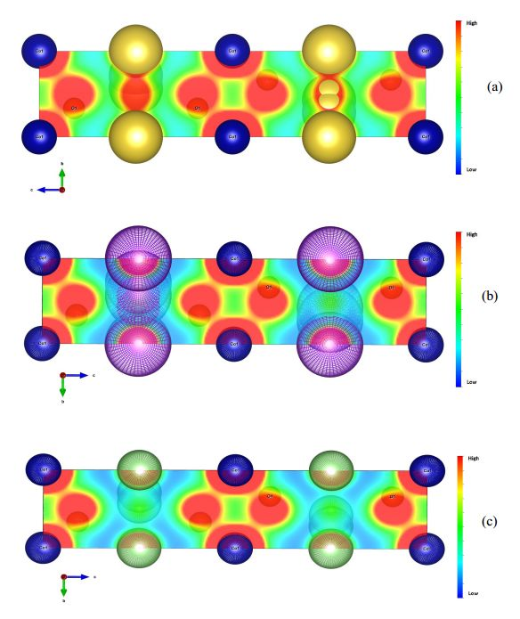
Fig.1. - View of hypothetical models of the layered structures AxCoO2, space group P63/mmc: (a) A=Na, x=1; (b) A=K, x=0.6 (c) A=Li, x=0.6. Qualitatively it is easy to see a role of an occupation factor and a size of the interlayer particles.
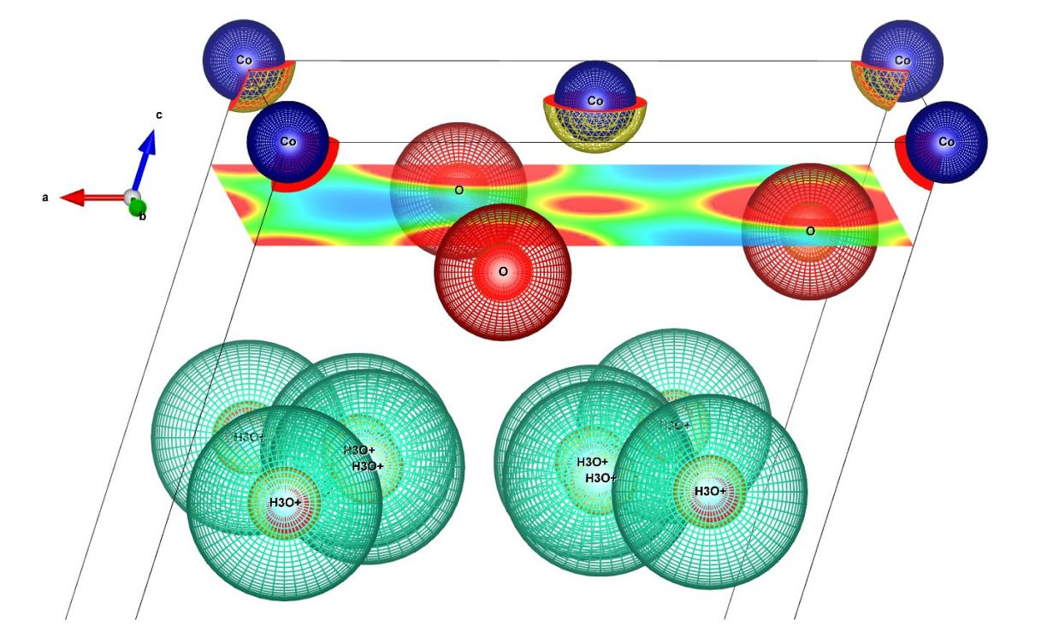
Fig.2. - The unit cell view for the model P'3 based on Na0.62CoO2 (space group C2/m) and electron-density distribution at the slice along oxygen atoms. Atomic coordinates and unit cell parameters from [15].
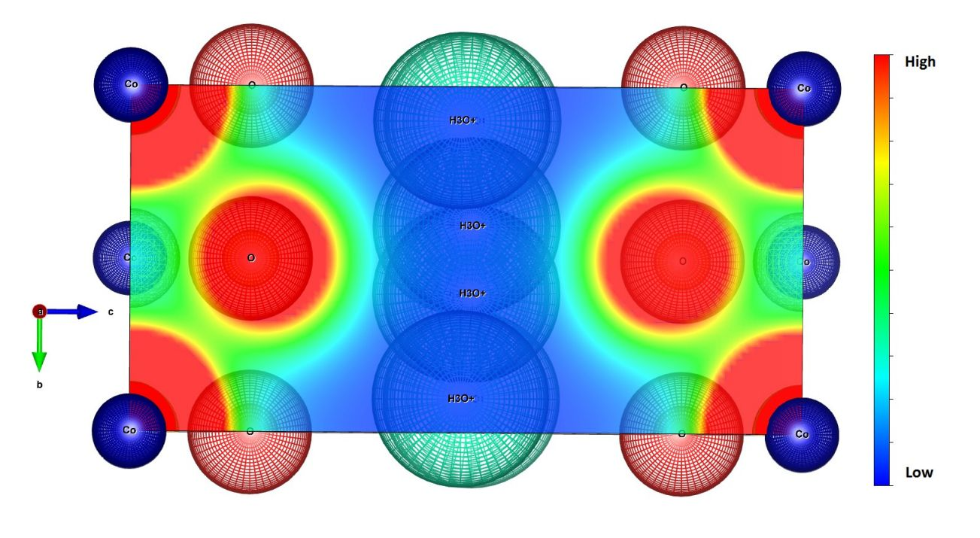
Fig.3. - Electron-density distribution and atoms location for (100) plane's view, P'3 model.
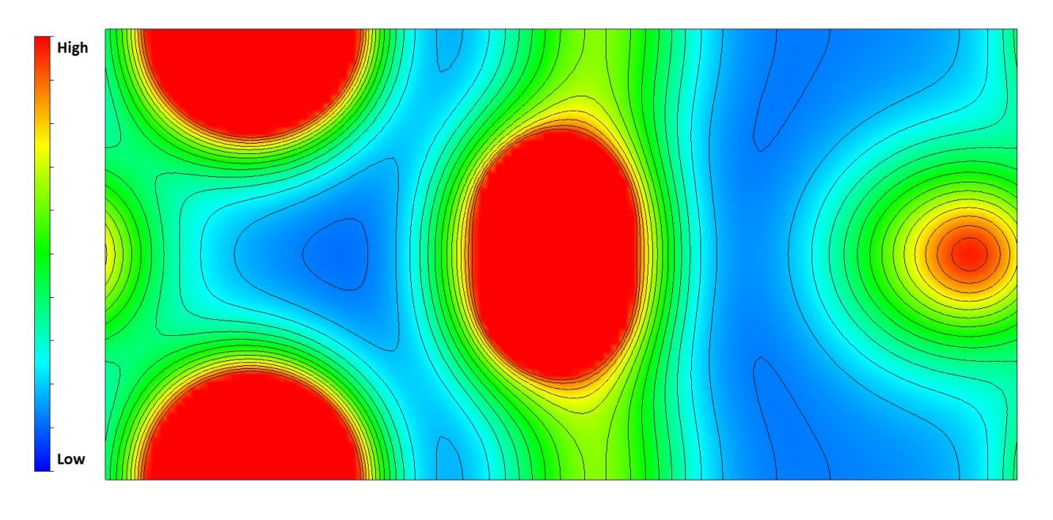
Fig.4. - Isosurfaces of electron-density distribution for P'3 model with intercalated ions. The view calculated along bxc plane with approximately 1.5Ǻ shift in the direction of a axis. It shows a high possibility of an influence of the interlayer particles (at the middle) on the relief of CoO2 layers (left and right sides of the picture).

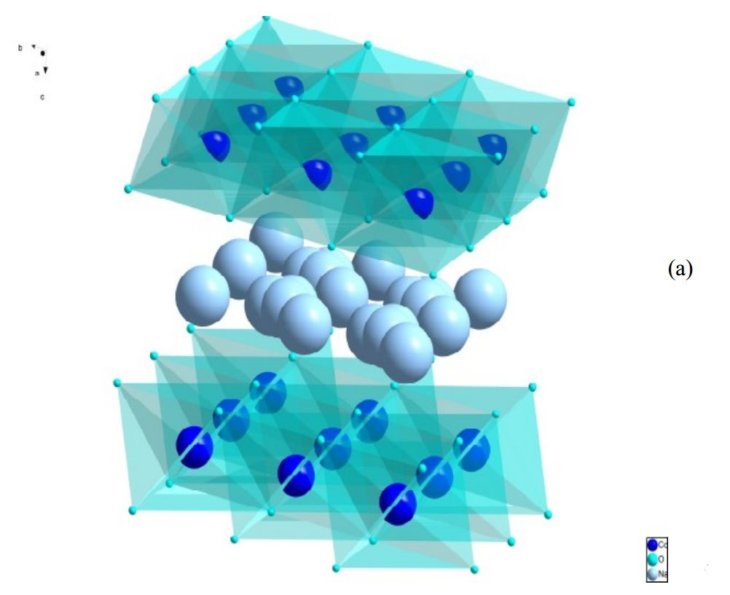
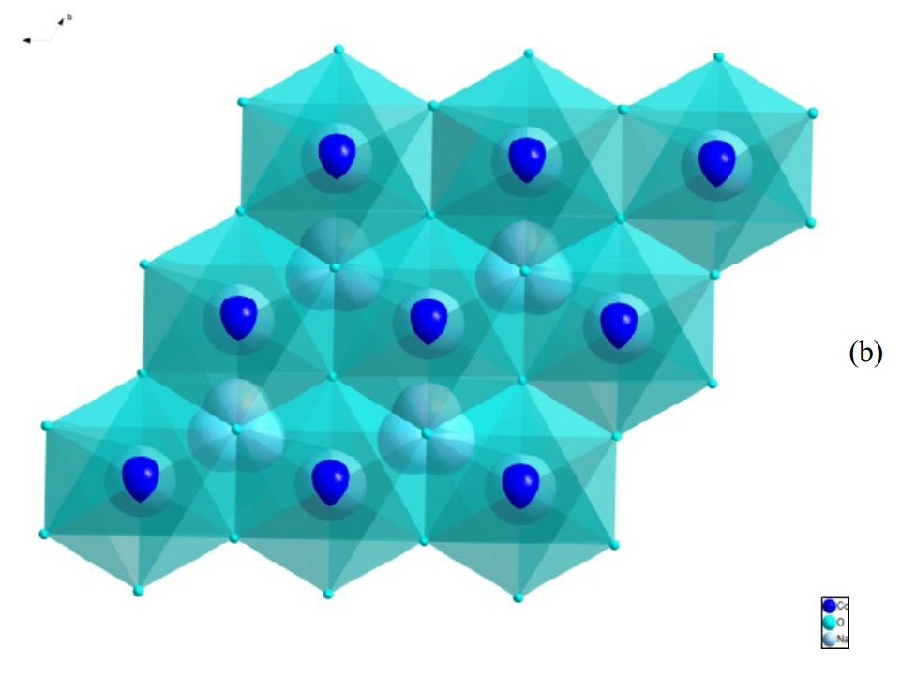
Fig.5. General model view (a) and a view along axb plane (b), P2-AxCoO2 structure, space group P63/mmc, unit cell constants and atomic coordinates from [9], [14] (A=Na, neutron diffraction data) and [15] (A=K, XRD data).

Theoretical approaches
In the case of effect “weak superconductivity” due to, for instance, one-dimensional (or fractional, less then 2D) nature, it would be easy to destroy it by critical current, because the value of critical field for that kind of materials is rather low. Thus, in some cases we can speak about “invisible” superconductivity effect, partly because of a little chance to find it accidentally via standard settings of equipment. For instance, for pressed powders, even with a high fraction of superconducting phase, boundaries between grains could play a role of a Josephson tunnel junction [23]. Another errors source would be a measurement method: DC or AC system, type of potential and current electrodes. Na⁺ ions patterning determines the Coulomb landscape and it has a great influence on electron properties. It could to be a reason for a non-superconducting behavior of Na_{0.35}CoO₂•0.7H₂O [25], Cs_{0.20}CoO₂•0.63H₂O, Rb_{0.30}CoO₂•0.36H₂O, K_{0.35}CoO₂•0.4H₂O [34], Na_{x}(H₃O)_{z}CoO₂ (x + z = 0.70) [35]. The papers [36], [37] report about a metallic conductivity in NaCo₂O₄ and KCo₂O₄. Moreover, in [36] the authors had mentioned about a hypothesis to use NaCo₂O₄ as a mother material for future study of superconductivity, but did not specify any directions for possible development that branch. It is possible to make even completely “clean” CoO₂ layers (x=0) [38], but there is no evidence of a transition to a superconducting phase. According to ideas of radii [39], H₃O⁺, could be treated as one big particle (e.g.[40]) , it contributes nearly the same “electrostatic roughness” as Na⁺ or K⁺, in the case if it will not form a partly charge disordered structure via high ionic conductivity by H⁺. Protons could be also sticky not just on H₂O host molecules forming H₃O⁺, but on an oxygen from a CoO₂ layer, the result would be a “clean” CoO₂ layer, doped by protons: CoO_{2-x} (OH) _{x}. A conception for origin of superconductivity for these types of materials includes the following principles: a) the smoothest potential relief is the best, b) protons making holes; the migration of protons/holes plays an important role. A detailed study of an exchange of alkali cations on oxonium in A_{x}MO₂ phases with different x (especially in the range 0.50≤x≤0.85 for the starting phases) and their physical properties will be a very useful investigation in order to proof the concept.

Discussions
The articles [41-43] are reporting about proton-exchanged HCoO₂ and more synthesis oriented, there is no conductivity or magnetic properties measurements. In the article [44], written by M.Onoda and Y.Kikuchi a part of mentioned program (x≈0.3) had been performed, but they did not find a superconducting transition for the material, determined as “H_{0.30}CoO₂'. The authors of [45] made the ionic exchanges in Na_{0.20}CoO₂ and K_{0.44}CoO₂. During the protonation, Na_{0.2}CoO₂ reduced to H_{0.96}Na_{0.04}CoO₂ and K_{0.44}CoO₂ to H_{0.98}K_{0.02}CoO₂. In the case of Li ion exchange reaction from Na_{0.2}CoO₂ to Li_{0.26}CoO₂, K_{0.44}CoO₂ to Li_{0.42}CoO₂ there is only a small amount of cobalt gets reduced from Co⁺⁴ to Co⁺³ state. Unfortunately, the authors of [45] show the plots resistivity vs temperature just for Na_{0.20}CoO₂ and AgCoO₂, but there are no conductivity or magnetic measurements data for the protonated samples.
If a sort of new superconducting phases are appearing by chance via impurities, it means they have a very little phase fraction amount, i.e. additionally to mentioned difficulties in conductivity measurements, magnetic measurements would not easy to perform as well. An impurity, the most common case for these rather hygroscopic compounds – water: it could be easily adsorbed by Li_{0.61}CoO₂ (O3), Na_{0.62}CoO₂ (P'3), K_{0.61}CoO₂ (P2) or by other A_{x}MO₂ phases with further ionic exchange (2) and the process (1) partly could take place as well; it will make a small amount of superconducting phase A_{x-b}(H₃O⁺)_{b}CoO₂ nearly on the surface. The amount of superconducting phase on the surface will be very little; it will probably appear as thin rings, loops along conductivity planes, plateaus or spots. We could hard to see superconductivity as a clear bulk transition; the result could appear as unexplained anomalies in magnetic properties, specific heat and transport properties data. There are some of them have to be examined more carefully in order to make a clear answer is it a superconducting impurity or not, e.g.: [15], fig.8, 11, 13 nearly 225K and 200K (graphs of electric resistivity, magnetic susceptibility and specific heat vs temperature for O3-Li_{0.61}CoO₂). Indirectly on that possibility is pointing out the article [46]: after the ionic exchange of Na⁺ on H3O+ in ordinary water with starting material Na_{0.51}CoO₂ the superconducting phase Na_{0.38}(H₃O⁺)_{0.13}CoO₂•1.2H₂O appears. The T_{c}=2.4K is rather low, but it confirms the general direction. Another “sign” of possible superconductivity could be seen from the graph of electronic conductivity for γ-'H_{x}CoO₂' phase [47] (chemical composition - H_{0.19}Na_{0.06}K_{0.25}CoO₂•H₂O, space group - R3m). The phase β(III)-H_{x}CoO₂(H₂O₂) [47] (chemical composition - H_{x}Na_{y}(H₂O)_{z}CoO₂, 0.7≤x≤0.9, 0.08≤y≤0.12, hexagonal symmetry suggested) exhibits lower electronic conductivity until about 230K, but then there are no electrical conductivity data. Unfortunately, there are no results of magnetic properties study in the article [47]. Some general ideas regarding structure-properties relations for various materials are describing in [48-51].

Conclusions
The results of preliminary analysis in crystal chemistry approximations lead to a possible formation of one-dimensional and fractionally dimensional conductive channels. An influence of H₃O⁺/H⁺ (from another point H+ could look like an oxygen vacancy) on superconductivity in the mainstream of possible high T_{c} enhancement could be confirmed via an experimental investigation. Primary, A_{x-b}(H₃O⁺)_{b}CoO₂ (A= alkaline cation) systems, should be chosen for even more detailed study, than was done before. Assuming the best results for a sample with the smoothest interlayer electrostatic potential and high concentration of mobile protons, the described approach would allow to determine superconducting phases with T_{c}>200K.

Acknowledgments
The author acknowledges the financial support (at the beginning of this work) by the Foundation for Fundamental Research on Matter in University of Groningen (the Netherlands), Southern Federal University (Russia) for the research databases access (between 2010 and 2013) and for the financial support (at the end of the work, project №213.01.-07.214/10) as well. Many thanks to Dr.O.Smirnova and D.Bublikov for stimulating discussions at initial stages of the article writing.

References
1. Johnston, D., Prakash, H., Zachariasen, W., Viswanathan, R. Materials Research Bulletin. 1973. V.8 pp.777-784.
2. Sleight, A., Gillson, J., Bierstedt, P. Solid State Communications. 1975. V.17. pp.27-28.
3. Bednorz, J., Müller, K. Zeitschrift für Physik B Condensed Matter. 1986. V.64 pp.189-193.
4. Gao, L., Xue, Y., Chen, F., Xiong, Q., Meng, R.L., Ramirez, D., Chu, C.W., Eggert, J.H., Mao, H.K. Phys. Rev. B. 1994. V.50. pp.4260-4263.
5. Fouassier, C., Matejka, G., Reau, J.-M., Hagenmuller, P. Journal of Solid State Chemistry. 1973. V.6. pp.532-537.
6. Fouassier, C., Delmas, C., Hagenmuller, P. Materials Research Bulletin. 1975. V.10. pp.443-449.
7. Delmas, C., Fouassier, C., Hagenmuller, P. Physica B+C. 1980. V.99. pp.81-85.
8. Delmas, C., Braconnier, J.-J., Fouassier, C., Hagenmuller, P. Solid State Ionics. 1981. V.3. pp.165-169.
9. Balsys, R.J., Davis, R.L. Solid State Ionics. 1996. V.93. pp.279-282.
10. Delmas, C., Fouassier, C., Hagenmuller, P. Materials Research Bulletin. 1976. V.11. pp.1483-1488.
11. Smirnova, O., Avdeev, M., Nalbandyan, V., Kharton, V., Marques, F. Materials Research Bulletin. 2006. V.41. pp.1056-1062.
12. Takada, K., Sakurai, H., Takayama-Muromachi, E., Izumi, F., Dilanian, R., Takayoshi, S. Nature. 2003. V.422. p.53.
13. Foo, M.L., Wang, Y., Watauchi, S., Zandbergen, H.W., He, T., Cava, R.J., Ong, N.P. Phys. Rev. Lett. 2004. V.92. p.247001.
14. Jorgensen, J.D., Avdeev, M., Hinks, D.G., Burley, J.C., Short, S. Phys. Rev. B. 2003. V.68. p.214517.
15. Pollet, M., Blangero, M., Doumerc, J.-P., Decourt, R., Carlier, D., Denage, C., Delmas, C. Inorg. Chem. 2009. V.48. pp.9671-9683.
16. Blangero, M., Decourt, R., Carlier, D., Ceder, G., Pollet, M., Doumerc, J.-P., Darriet, J., Delmas, C. Inorganic Chemistry. 2005. V.44. pp.9299-9304.
17. Blangero, M., Carlier, D., Pollet, M., Darriet, J., Delmas, C., Doumerc, J.-P. Phys. Rev. B. 2008. V.77. p.184116.
18. Roger, M., Morris, D.J.P., Tennant, D.A., Gutmann, M.J., Goff, J.P., Hoffmann, J.-U., Feyerherm, R., Dudzik, E., Prabhakaran, D., Boothroyd, A.T., Shannon, N., Lake, B., Deen, P.P. 2007. Nature. V.445. pp.631-634.
19. Berthelot, R., Carlier, D., Delmas, C. Nature Materials. 2011. V.10. pp.74-80.
20. Shukaev, I.L., Volochaev, V.A. Russian Journal of inorganic chemistry (in russian). 1995. V.40. p.2056.
21. Shilov, G.V., Nalbandyan, V.B., Volochaev, V.A., Atovmyan, L.O. International Journal of Inorganic Materials. 2000. V.2. pp.443-449.
22. Politaev, V., Nalbandyan, V., Petrenko, A., Shukaev, I., Volotchaev, V., Medvedev, B. Journal of Solid State Chemistry. 2010. V.183. pp.684 - 691.
23. B.Josephson, Physics Letters. 1962. V.1. pp.251 - 253.
24. Takada, K., Sakurai, H., Takayama-Muromachi, E., Izumi, F., Dilanian, R.A., Sasaki, T. Journal of Solid State Chemistry. 2004. V.177. pp.372 - 376.
25. Sakurai, H., Takada, K., Izumi, F., Dilanian, R., Sasaki, T., Takayama-Muromachi, E. Physica C: Superconductivity. 2004. V.412-414, Part 1.pp.182-186.
26. Park, S., Lee, Y., Vogt, T. Solid State Communications. 2008. V.148. pp.271-273.
27. Takada, K., Fukuda, K., Osada, M., Nakai, I., Izumi, F., Dilanian, R.A., Kato, K., Takata, M., Sakurai, H., Takayama-Muromachi, E., Sasaki, T. J. Mater. Chem. 2004. V.14. pp.1448-1453.
28. Jorgensen, J.D., Avdeev, M., Hinks, D.G., Barnes, P.W., Short, S. Phys. Rev. B. 2005. V.72. pp.224515.
29. Barnes, P.W., Avdeev, M., Jorgensen, J.D., Hinks, D.G., Claus, H., Short, S. Phys. Rev. B. 2005. V.72. pp.134515.
30. Hinuma, Y., Meng, Y.S., Ceder, G. Phys. Rev. B. 2008. V.77. pp.224111.
31. Volochaev, V.A. Private communication. 1997.
32. Momma, K., Izumi, F. Journal of Applied Crystallography. 2011. V.44. pp.1272-1276.
33. Pennington, W.T. Journal of Applied Crystallography. 1999. V.32. pp.1028-1029.
34. Tanga, H., Lina, H., Wangb, M., Liaoa, M., Hsuc, F., Mokc, B., Liua, J., Beasleya, M., Sheud, H., Wue, M. Journal of Solid State Chemistry. 2006. V.179. pp.2728–2731.
35. Sakurai, H., Osada, M., Takayama-Muromachi, E. Chem.Mater. 2007. V.19. pp.6073-6076.
36. Tanaka, T., Nakamura, S., Iida, S. Jpn. J. Appl. Phys. 1994. V.33. L581-582.
37. Nakamura, S., Ohtake, J., Yonezawa, N., Iida, S. J. Phys. Soc. Jpn. 1996. V.65. pp. 358-360.
38. Motohashi, T., Katsumata, Y., Ono, T., Kanno, R., Karppinen, M., Yamauchi, H. Chemistry of Materials. 2007. V.19. pp.5063-5066.
39. Shannon, R.D., Prewitt, C.T. Acta Crystallogr. B. 1969. V.25. pp.925-46.
40. Roziere, J., Williams, J. J. Chem. Phys. 1978. V.68. p.2896.
41. Sato, K., Hagizuka, S., Inoue, Y. Solid State Ionics. 1993. V.66. pp.197-200.
42. Fernandez-Rodriguez, J.M., Hernan, L., Morales, J., Tirado, J.L. Mat. Res. Bull. 1988. V.23. pp.899-904.
43. Kittaka, S., Uchida, N., Miyashita, I., Wakayama, T. Colloids and Surfaces. 1989. V.37. pp.39-54.
44. Onoda, M., Kikuchi, Y. Journal of Physics: Condensed Matter. 2007. V.19. p.346206.
45. Shivakumara, C., Hegde, M. Proc. Indian Acad. Sci. (Chem. Sci.) 2003. V.115. pp.447-457.
46. Banobre-Lopez, M., Rivadulla, F., Lopez-Quintela, M., Rivas, J. JACS Communications. 2009. V.131. pp.9632-9633.
47. Butel, M., Gautier, L., Delmas, C. Solid State Ionics. 1999. V.122. pp.271-284.
48. Polozhentsev, O., Sukharina, G., Guda, A., Shapovalov, V., Podkovirkina, Yu., Chainikov, A., Bugaev, A., Pol, A. Inženernyj vestnik Dona (Rus), 2013, №4 Url: ivdon.ru/ru/magazine/archive/n4y2013/2016 (Rus).
49. Shabel'skaya, N., Ul'yanov, A., Talanov, M., Reznichenko, L., Shilkina, L. Inženernyj vestnik Dona (Rus), 2014, №1 Url: ivdon.ru/ru/magazine/archive/n1y2014/2297 (Rus).
50. Livanov, D., Manokhin, S. Physica B: Condensed Matter. 2002. V.316. pp.335-338.
51. Varlamov, A., Balestrino, G., Milani, E., Livanov, D. Advances in Physics. 1999. V.48. pp.655-783.

