Nanostructured Composites Based on Interpenetrated Polymer Networks
Kinds, Classification, Properties, Synthesis, Application
O. Figovsky, D. Beilin

Polymate Ltd.-International Nanotechnology Research Center,
MigdalHaEmek, Israel

Abstract: Using an interpenetrating polymer networks (IPN) principle in production of composite materials provides an unique possibility to regulate their both micro- and nano- structures and properties. By changing the IPN formation conditions (as a result of polymerization and ratio of components, temperature, pressure, catalyst content, introduction of filler and or ionic group) one may obtain the material with desirable properties. Different types of IPN are prepared by using traditional polymers: polyurethanes, including nonisocyanate polyurethanes, epoxies and acrylates; non- organic filler scan be used as the cluster system. The article discusses their basic synthesis methods for IPNs their principal features and characteristics.
Key words: interpenetrating polymer networks, cross linked polymers, classification of IPN, properties of IPN.

Introduction

Interpenetrating polymer networks (IPNs) are unique “alloys” of crosslinked polymers in which at least one network is synthesized and/or crosslinked in the presence of the other. Unlike chemical blends, there are, ideally, no covalent bonds between components in IPNs [1-4]. Thus, there is some type of "interpenetration." However, the term interpenetrating polymer network was coined before current aspects of phase separation and morphology were understood. Now we know that most IPNs do not interpenetrate on a molecular scale; they may, however, form finely divided phases of only tens of nanometers in size. Many IPNs exhibit dual phase continuity, which means that two or more polymers in the system form phases that are continuous on a macroscopic scale [2,4].
IPNs are often created for the purpose of conferring key attributes of one of the components while maintaining the critical attributes of another. In some cases, entirely new, and sometimes surprising properties are exhibited by the IPN that are not observed in either of the two single networks alone [4].
When two or more polymers are mixed, the resulting composition can be called a multicomponent polymer material. There are several ways to mix two kinds of polymer molecules (Fig.1).Simple mixing, as in an extruder, results in a polymer blend. If the chains are bonded together, graft or block copolymers result: Bonding between some portion of the backbone of polymer I and the end of polymer II, the result is called a graft copolymer; chains bonded end to end result in block copolymers. Other types of copolymers include AB-cross linked copolymers, where two polymers make up one network, and the IPNs, and semi-IPNs (SIPNs) [2].
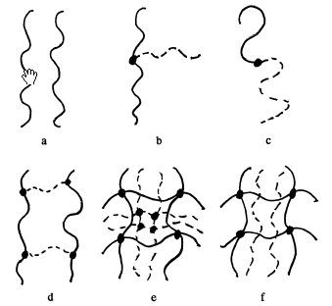

Fig.1. - Six basic combinations of two polymers: a-polymer blend, no bonding between chains; b-graft copolymer; c- block copolymer; d- AB-graft copolymer; e- IPN; f- SIPN. Structures a-care thermoplastic; structures-f are thermoset [2].

Kinds of IPNs

From a synthetic standpoint, IPNs come in two varieties:
- Sequential IPN in which one network is swollen and polymerized in the presence of the other;
- Simultaneous IPN, in which both of the network precursors are synthesized at the same time by independent, non-interfering routes.
When one of the two polymers is linear (uncrosslinked), a semi-IPN results and when both of the polymers are identical, a homo-IPN results. An important parameter that must be considered in the fabrication of IPNs is the mutual miscibility of the interpenetrating polymers; in general, polymers do not mix well with each other, resulting in the phase separation of the resultant blend. However, because cross linking provides a way to “enforce” mixing between two otherwise immiscible materials, there are virtually endless combinations of polymers worthy of exploration as IPNs for a variety of applications [4].
IPNs can be made in many different ways. Brief definitions of some of the more important IPN materials are as follows [2]:
- Sequential IPN. Polymer network I is made. Monomer II plus cross-linker and activator are swollen into network I and polymerized in situ (Fig.2A). The sequential IPNs include many possible materials where the synthesis of one network follows the other.
- Simultaneous interpenetrating network (SIN). The monomers or prepolymers plus cross-linkers and activators of both networks are mixed. The reactions are carried out simultaneously, but by noninterfering reactions. An example involves chain and step polymerization kinetics (Fig. 2B).
- Latex IPN. The IPNs are made in the form of latexes, frequently with a core and shell structure. A variation is to mix two different latexes and then form a film, which cross-link both polymers. This variation is sometimes called an interpenetrating elastomer network (IEN).

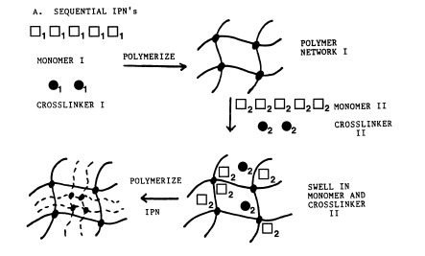
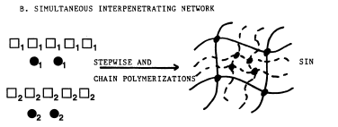
Fig.2 - Basic synthesis methods for IPNs. A- Sequential IPNs; B- simultaneous interpenetrating polymer networks (SINs) [2].

- Gradient IPN. Gradient IPNs are materials in which the overall composition or cross-link density of the material varies from location to location on the macroscopic level. For example, a film can be made with network I predominantly on one surface, network II on the other surface and a gradient in composition throughout the interior.
- Thermoplastic IPN. Thermoplastic IPN materials are hybrids between polymer blends and IPNs that involve physical crosslinks rather than chemical crosslinks. Thus, these materials flow at elevated temperatures, similar to the thermoplastic elastomers, and at use temperature, they are cross-linked and behave like IPNs. Types of cross links include block copolymer morphologies, ionic groups, and semicrystallinity.
- Semi-IPN. Compositions in which one or more polymers are crosslinked and one or more polymers are linear or branched are semi-IPN (SIPN).

Classification of IPN [3]

Different forms of IPN are illustrated in Fig.3
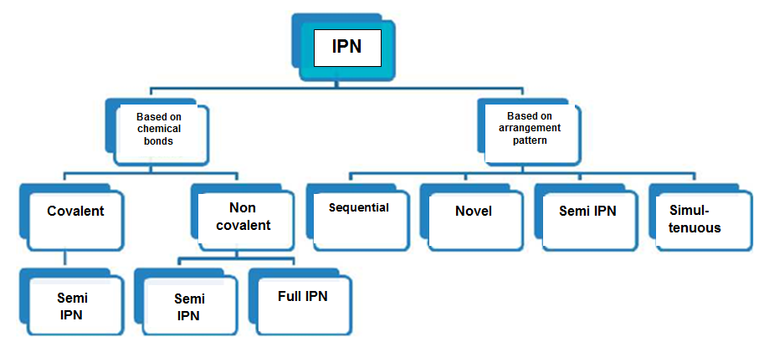
Fig.3.-Different forms of IPN [3]

IPN Based on Chemical Bonding
Covalent cross linking leads to formation of hydro gels with a permanent network structure, since irreversible chemical links are formed. This type of linkage allows absorption of water and/or bioactive compounds without dissolution and permits drug release by diffusion.
- Covalent Semi IPN- A covalent semi IPN contains two separate polymer systems that are cross linked to form a single polymer network.
- Non Covalent Semi IPN- A noncovalent semi IPN is one in which only one of the polymer system is cross linked.
- Non Covalent Full IPN- A noncovalent full IPN is a one in which the two separate polymers are independently crosslinked.

IPN Based on Arrangement Pattern
- Sequential IPN- In sequential IPN the second polymeric component network is polymerized following the completion of polymerization of the first component network.
- Novel IPN- Polymer comprising two or more polymer networks which are at least partially interlocked on a molecular scale but not covalently bonded to each other and cannot be separated unless chemical bonds are broken.
- Semi IPN- If only one component of the assembly is cross linked leaving the other in a linear form, the system is transferred as semi IPN.
- Simultaneously IPN- Simultaneously IPN is prepared by a process in which both component networks are polymerized concurrently, the IPN may be referred to as a simultaneously IPN.

Properties of IPN [3]

- A gel composed of two interpenetrating networks by cross linking a polymer (or polyelectrolyte) into a pre-existing highly cross linked network of a polymer (or polyelectrolyte) of a different kind have increased elastic and mechanical properties which was measured by the stress-strain behavior and comparing their elastic modules and breaking points.
- According to US Patent data the calculated true stress per unit solid and strain shows that PGA/PAA IPNs are much stronger than either the individual polymer networks or copolymers. The effect of IPN formation on tensile strength is nonlinear, as the maximum strength is many times higher than that of PEG-PAA copolymer. The elastic modules and tensile strength can be modified by changing the molecular weight.
- Oxygen permeability- IPN hydro gels composed of PEG as the first network and a second network of poly acrylic acid had oxygen permeability of 95.9±28.5 Barrers.
- Shape memory-Materials are said to show shape memory effect if they can be deformed and fixed into a temporary shape and recover their original permanent shape only on the exposure of external stimuli, like heat, light etc.
- Equilibrium water content- IPN can swell in solvent without dissolving. The water content of hydro gels was evaluated in terms of the swollen weight to dry weight ratio. The dry hydro gel was weighed and then immersed in water as well as phosphate buffered saline. At regular intervals the swollen gel was lifted, patted dried and weighed until the equilibrium was attained. The percentage of equilibrium water content (WC) was calculated from the swollen and dry weight of hydrogel:
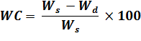
where, W_{s} and W_{d} are weight of swollen and dry hydro gels respectively.
- IPN systems are known to increase the phase stability of the final product.
- Thermodynamic incompatibility can be overcome due to the permanent interlocking of the network segments.
- High thermostability.
- Good dielectric properties.
- Radar transparency.
- Nutrient permeability.
- Optical clarity- The percentage of light transmittance was found to be 90% and the refractive index was found to be 1.35.

Synthesis of Some IPN

Scheme of mechanisms for formation of hydrogels is shown in Fig.4
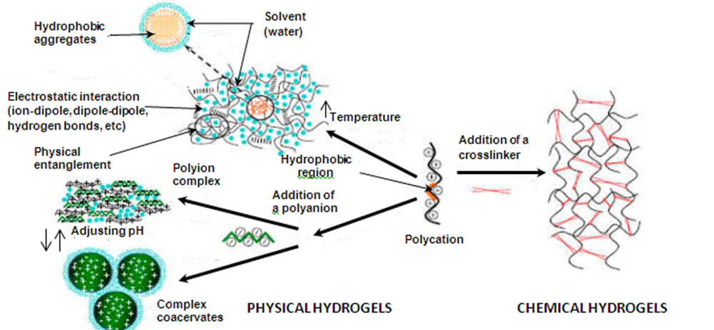

Fig.4.-Overview of mechanisms for formation of physical and chemical hydrogels [3]

Synthesis of IPN [3,5]
The Fig. 5 shows steps in IPN preparation.
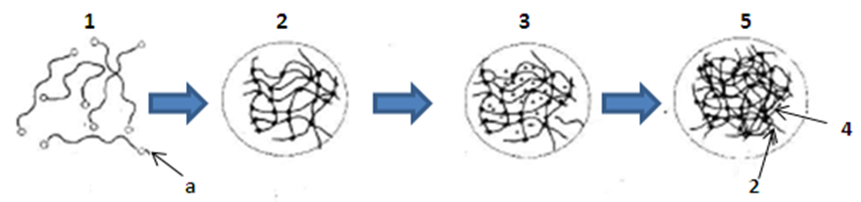
Fig. 5. IPN hydro gels composed of poly (ethyleneglycol) macromere (PEGM) and chitosan [3].
The starting material to make the hydro gel was a solution of telechelic macro monomers (1) with functional end groups (a). They were polymerized to form a polymer network followed by the addition second polymer (4) of hydrophilic monomers (3) which were polymerized and cross linked in the presence of the first polymer(2). This resulted in the formation of IPN hydro gel (5). Polyethylene glycol (PEG) can also be used a first polymer as it is biocompatible, soluble in aqueous solution and gives wide range of molecular weights and chemical structures. IPN hydro gel was also prepared by UV initiated free radical polymerization. It used the first network as PEG diacrylate (PEG-DA) or PEG dimethacrylate (PEG-DMA) dissolved in phosphate buffered saline (PBS).
We shall consider in detail the problem of polyurethane and epoxy based IPN.
The importance of polyurethane-based IPNs needs special emphasis. Such materials are relatively easy to synthesize and have outstanding properties. The polyurethane elastomers may serve as network in a sequential IPN synthesis or, in prepolymer form, may serve as one component in simultaneous interpenetrating networks. Several methods of synthesis between the classical sequential and simultaneous methods have been worked out [2].
Meyer and co-workers [6-10] investigated the composition cross-polyurethane-inter-cross-poly (methyl methacrylate). In general, the synthesis involved an aromatic triisocyanate and a polyether glycol catalyzed by stannous octanoate. The poly (methyl methacrylate) (PMMA) network resulted from an AIBN-ini-tiated (azobisisobutyronitrile-initiated) free radical polymerization with a trimethacrylatecrosslinker. All of the components were mixed together. The polyurethane (PU) network was allowed to form first at room temperature, followed by heating to initiate the polymerization of the methyl methacrylate (MMA) monomer. The resulting IPNs exhibited two loss peaks in tan 8-tem-perature studies, but the glass-transition temperatures were shifted inward significantly and broadened. Thus Meyer et al. concluded that these materials exhibited incomplete phase separation [2].

Jin and Meyer [11] studied the kinetics of reaction of these IPNs via Fourier transform infrared spectroscopy (FTIR). The PUnetwork was formed at room temperature again; then the PMMA was free radical polymerized at 60 °C. The authors adopted the term "in situ" sequential IPNs for such materials to emphasize that all the reagents are introduced simultaneously, but that the networks are formed sequentially. This formulation is an example of kinetics partway between sequential and simultaneous syntheses [2].
Jin et al. [2, 12] showed that the polyurethane has two effects on the formation of the acrylic phase:
- By conferring a very high viscosity on the reaction medium from the very beginning of the polymerization process, an initial high reaction rate and early gelation effect is induced.
- The polyurethane clearly acts as a diluent and keeps the T_{g} of the reaction medium below the T_{g} of the PMMA; hence, complete monomer to polymer conversion at 50-70 °C is allowed. Polymerization usually stops at or just beyond the point of glassification, due to slowed diffusion processes [2,13].
Allen et al. [2, 14-19] carried out an interstitial polymerization of vinyl monomers within PU gels. The reaction scheme was as follows:
Allen et al. pointed out that the maximum swelling capacity of the gel should not be exceeded (taking into account χ₁) or macrosyneresis will occur. On the other hand, the cross-link density must be high enough to prevent macroscopic phase separation on polymerization of the MMA. For all of the systems considered by Allen et al., the PU was gelled at room temperature and the MMA was initiated at elevated temperatures, in a manner similar to the work of Meyer et al. [2,11,12].
Although the focus of these papers has been on the polyurethane (PU), note that each of these papers also has poly(methylmethacrylate) as the mate polymer. This pair develops excellent mechanical behavior over a wide range of compositions.
PUsare among the most used polymers in many modern technologies [20]. However, the use of toxic components, such as isocyanates, in the manufacturing process can render PU production extremely toxic and dangerous [21]. Noniso-cyanate sources for PU production have been sought for a long time.
Isocyanates are critical components used in conventional polyurethane products such as coatings and foam. However, exposure to isocyanates is known to cause skin and respiratory problems and prolonged exposure has been known to cause severe asthma and even death. Isocyanates are also toxic to wildlife. When burnt, isocyanates form toxic and corrosive fumes including nitrogen oxides and hydrogen cyanide. Due to these hazards, isocyanates are regulated as by the EPA and other government agencies.
Non-isocyanate polyurethane (NIPU) based on the reaction of polycyclic carbonates and poly-amines are known for more than 50 years. Fundamentals for the practical application of NIPU on the basis of five-membered cyclic carbonates (1, 3-dioxolan-2-ones) in coatings, sealants, adhesives, etc. were largely developed by O. Figovsky in the 1970- 1980's [22]. Recently, some reviews dedicated to synthesis of cyclic carbonates and NIPU have been presented [23-25]. In these works the advantages of NIPU have been described in detail.
We had been created materials on the basis of hidroxyurethane and epoxy NPI, which are described in a number of patents of the authors and their collaborators [26-33]. It should be emphasized the entirely new developments contained in patents [26] and [28]. The first of these provides information about nonisocyanatepolyurethanes (NIPU) on the oligomers’ basis with terminal cyclocarbonate and epoxy groups; nanostructured NIPU are described in the second patent.
Applications of IPN Technology

The IPNs have many applications, both proposed and in practice. Some commercial materials are shown in Table 1 [2].
Table 1.
IPN Commercial Materials
Composition | Application
SEBS¹-polyester | Automotive parts
Silicone rubber-PU² | Gears ormedical
PU-polyester-styrene | Sheetmoldingcompounds
PP³-EP⁴ | Automotiveparts
Rubber- PE | Automotiveparts
Rubber- PP | Tough plastic
EPDM⁵-PP | - Auto bumper parts , wire and cable  - Tires, hoses, belts and gaskets  - Outdoor weathering  - Tubing, liners  - Paintable automotive parts
Anionic-cationic | Ion exchange resins
Acrylic-urethane-polystirene | Sheeting molding compounds
Acrilic-based | Artificialteeth
Vinyl-phenolic | Damping compounds
HNIPU⁶ | - Industrial Flooring  - Paints  - Coatings  - Artificial leather  - Rigid and Flexible Foams  - Adhesives
Table 1.
Continue
Composition | Application
RubCon⁷ | - Industrial Flooring  - Galvanic and Electrolysis Baths  - Supports and Foundations  - Underground Structures  - High- Speed Railroad Ties
SPC⁸ | - Storage Tanks for Hot and Cold Acids  - Lining of an Equipment, Reservoirs and Building Structures  - Vessel Heads  - Vaults And Diaphragms  - Pickling Baths for Metallurgical Plants
LEM⁹ | - Rubber Sheet Linings  - Pickle Pipeline and Tanks  - Liquid Complex Fertilizers.  - Coating of Bottom of an Automobiles  - Protection From Corrosive Salts  - Line Mixing Tanks  - Refrigerant Bottom Boxes
¹Styrene Ethylbuthylene Styrene,
²Polyurethane,
³Polypropylene,
⁴Ethylene Propylene,
⁵Ethylene Propylene Diene Monomer ,
⁶Hybrid Nonisocyanate Polyurethane ,
⁷ Polymer concrete Basedon Vulcanized Polybutadine Matrix,
⁸Polymer Concrete Based on an Organic-Silicate Matrix,
⁹Liquid Ebonite Mixtures.

Although most applications involve bulk polymeric materials, ion exchange resins make a particularly interesting application. IPN ion exchange resins usually have anionically and cationically charged networks within the same suspension particle, whereas other types have charged networks on different particles. An outstanding example is artificial teeth. According to [2, 34] the material is substantially a homo-IPN of poly(methyl methacrylate).
One especially interesting are the nanostructured polymer compositions HNIPU, RubCon, SPC and LEM (Table 1) in context of their highest properties and exciting prospective of application. These materials were developed and introducted into the industry by companies Nanotech Industry, Inc & Polymate Ltd.-INRC (USA-Israel). The companies received “2015 Presidential Green Chemistry Challenge Award”. From the official statement about getting the award: “As a recipient of this prestigious award, you are distinguished at the national level as in innovator in green chemistry”.

REFERENCES:
- Grigoryeva O. Reactive Fictionalization and Compatibilization of Components of Interpenetrating Polymer Networks, J. Scientific Israel-Technological Advantages, vol.6, no.3-4, 2004
- Sperling L.H., Interpenetrating Polymer Networks: An Overview. Url:pubs.acs.org/doi/pdf/10.1021/ba-1994-0239.ch001
- Shivashankar M., Mandal B.K, A Review On Interpenetrating Polymer Network, International Journal of Pharmacy and Pharmaceutical Sciences,Vol 4, Suppl 5, 2012. Url: ijppsjournal.com/Vol4Suppl5/4303.pdf
- Myung D., Waters D., Wiseman M., Duhamel P-E., Noolandi J., Ta C.N., Frank C.W., Progress in the development of interpenetrating polymer network hydrogels, Polym . Adv Technol. 2008 Apr 28; 19(6): 647–657. Url: ncbi.nlm.nih.gov/pmc/articles/PMC2745247/
- Myung D, Ta C., Frank C. ,Won-Gun Koh, Noolandi J. Interpenetrating Polymer Network Hydrogel Corneal Prosthesis, US Patent 2007/0179605 A1
- Hermant, I.; Damyanidu, M.; Meyer, G. C. Polymer 1983, 24, 1419.
- Morin, A.; Djorao, H.; Meyer, G. C. Polym. Eng. Sci. 1983,23, 394.
- Djomo, H.; Widmaier, J. M.; Meyer, G. C. Polymer 1983, 24, 1415.
- Hermant, I.; Meyer, G. C. Eur. Polym. 1984,20, 85.
- Jehl, D.; Widmaier, J. M.; Meyer, G. C. Eur. Polym. . 1983,19, 597.
- Jin, S. R.; Meyer, G. C. Polymer 1986, 27, 592.
- Jin, S. R.; Widmaier, J. M.; Meyer, G. C. Polymer 1988,29, 346
- Gillham, J. K. Encyclopedia of Polymer Science and Engineering, 2nd ed.; Wiley-Interscience: New York, 1986; Vol. 4, p 519.
- Allen, G.; Bowden, M. J.; Bhmdell, D. J.; Hutchinson, F. G.; Jeffs, G. M.; Vyvoda, Polymer 1973,14, 597.
- Allen, G.; Bowden, M. J.; Bhmdell, D. J.; Jeffs, G. M.; Vyvoda, J.; White, T. Polymer 1973,14, 604.
- Allen, G; Bowden, M. J.; Lewis, G.; Blundell, D. J.; Jeffs, G. M. Polymer 1974, 15, 13.
- Allen, G.; Bowden, M. J.; Lewis, G.; Bludell, D. J.; Jeffs, G. M.; Vyvoda, J. Polymer 1974,15, 19.
- Allen, G.; Bowden, M. J.; Todd, S. M.; Blundell, D. J.; Jeffs, G. M.; Davies, W. E. A Polymer 1974, 15, 28.
- Blundell, D. J.; Longman, G. W.; Wignall, G. D.; Bowden, M. J. Polymer 1974, 15, 33.
- Thomson T. Polyurethanes as Specialty Chemicals: Principles and Applications, CRC Press, 2005. 190 p.
- Meier-Westhues U. Polyurethanes: Coatings, Adhesives and Sealants, Vincentz Network GmbH & Co KG, Hanover, 2007, 344 p.
- Soviet Union patents: SU529197, 1976; SU563396, 1977; SU628125, 1978; SU630275, 1978; SU659588, 1979; SU671318, 1984; SU707258, 1984; SU903340, 1982; SU908769, 1982; SU1126569, 1984;SU1754747, 1992; SU1754748, 1992.
- Potashnikova R., Leykin A., Figovsky O., Shapovalov L. Napylenie Neizotsianatnykh Poliuretanovykh Izolyatsionnykh Pen. Inženernyj vestnik Dona (Rus), 2014, №3 Url: ivdon.ru/ru/magazine/archive/n2y2014/2323 (Rus).
- Figovsky O., Shapovalov L., Leykin A., Birukova O., Potashnikova R. Progress In Elaboration Of Nonisocyanate Polyurethanes Based on Cyclic Carbonates. Inženernyj vestnik Dona (Rus), 2014, №3 Url: ivdon.ru/ru/magazine/archive/n3y2014/2530 (En)
- Guan J., Song Y., Lin Y., Yin X., ZuoM.,Zhao Y., Tao X., ZhengQ.Progress in Study of Non-isocyanate Polyurethane”, Ind. Eng. Chem. Res. 2011, 50, 6517 – 6527.
- Figovsky O. Hybrid Nonisocyanate Polyurethane Network Polymers and Composites Formed Therefrom, US 6,120,905(2000).
- Figovsky O., ShapovalovL., Preparation of Oligomeric Cyclocarbonate sand their Use in Nonisocyanateor Hybrid Nonisocyanate Polyurethanes, US Patent 7,232,877 (2007).
- Birukov O., Beilin D., Figovsky O., Leykin A., Shapovalov L. Nanostuctured Hybrid Oligomer Composition, US Patent 7,820,779(2010).
- Birukov O., Figovsky O., Leykin A.,Shapovalov L. Epoxy-Amine Composition Modified With Hydroxyalkyl Urethane, US Patent 7,989,553(2011).
- Birukov O., Figovsky O., Leykin A., Potashnikov R., Shapovalov L. Method of Producing Hybrid Polyhydroxyurethane Network on a Base of Carbonated-Epoxidized Unsaturated Fatty Acid Triglycerides, US Patent Application2012/0208967.
- Figovsky O.,Potashnikov R., Leykin A., Shapovalov L., Sivokon S. Method For Forming A Sprayable Nonisocyanate Foam Composition, US Patent Application 2015/0024138.
- Figovsky O., Leykin A., Potashnikov R., Shapovalov L., Birukov O. Radiation-Curable Biobased Flooring Compositions With Nonreactive Additives, US Patent Application14/160,297 (2014).
- Birukov O., Figovsky O., Leykin A., Shapovalov L. Hybrid Epoxy-Amine Hydroxyurethane-Grafted Polymer US Patent Application 14/296,478 (2014).
- Roemer, F. D.; Tateosian, L. H. European Patent 0,014,515, 1984.

