The light hollow wall elements and method of building walls with the use of such elements

O. Figovsky
INRC Polymate (Israel) and Nanotech Industries, Inc. (USA)
Аннотация: В данной статье автор рассматривает разные способы возведения стен зданий и предлагает метод возведения стен зданий с использованием новых частей стен, который требует относительно низкой трудозатратности, позволяет не использовать мощные краны и металлические формы, и, таким образом, является более экономичным.
Ключевые слова: методы возведения стен зданий, новые части стен, экономичный способ возведения стен

INTRODUCTION
There are a number of methods of erection of walls of buildings. Few of commonly used are below [1-8]:
- Method whereby a reinforced concrete cage of a building is placed, then the walls are erected by means of laying blocks on cement mortar between the members of this cage, after which finishing work is implemented. The main drawback of this method using the said blocks as wall elements is its high labor input and the necessity of implementing finishing work.
- Method which is free of the aforesaid drawback. In this method elements of wall are reinforced concrete curtain wall panels having a heat insulation layer. The wall panels are placed between the elements of building cage and are jointed to it. A drawback of this method is the necessity of using powerful cranes due to the significant weight of the curtain wall panels and also a high fabrication cost of these panels. For this reason this method is not economical enough.
- Method wherein wall elements are created in the course of erecting the building. In this case the wall elements are encased in concrete in metal double-sided traveling forms together with columns and other structures of the building’s bearing frame. Simultaneously with the concreting or after it a heat-insulation layer is created in this element. A drawback of this method consists in the necessity of using great quantities of metal forms and this affects the economical operation of the building wall erection.

We suggest the new wall’s elements and the method of erecting the walls of buildings with the use of these elements, which required a relatively low labor input, does not use powerful cranes and metal forms and thus is more economical [9-11].

NEW WALL’S ELEMENT AND METOD OF ITS ASSEMBLING

Element of the wall comprises a rigid-jointed space frame shaped as a wall an exterior facing slab and an interior slab. These slabs are secured on opposite sides of the above' frame. In this case the frame together with the said slabs forms a space intended for filling in with heat-insulation material and for shaping in it reinforced concrete frame elements of the building (columns, beams etc.).
The method of erecting the walls of buildings using light hollow wall elements includes the following sequential steps:
- Installation of rigid reinforcing cage of the buildings columns. This cage is made of the angular profiles.
- Attachment of the basic mounting appliances to the above rigid reinforcing cage and to reinforced concrete slab of the previous stories span. This ensures stability of the wail during building works and accuracy of the wall elements setting.
- Setting of the light hollow wail elements in the erected wall and setting of the additional reinforcing reds in the columns and walls required according to calculation.
- Filling with concrete of the hollow space, which was formed after setting in the design position of the above wall elements.
- Placement of concrete in the reinforced concrete floor slab ever the erected storey simultaneously filling with concrete the part of the hollow space in the wall above the window level.
The essence of the suggestion is illustrated by some sketches (Figures 1,2).

5
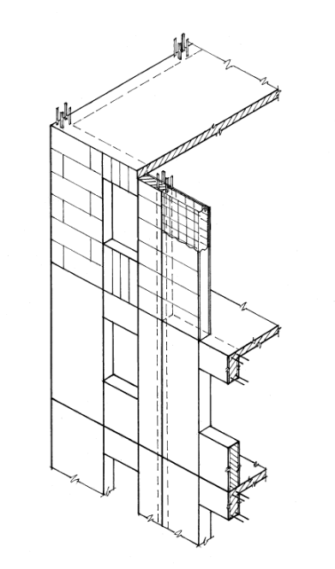
1
2
3
4
5
6
5
4

Figure 1. Section of a biding wall erected in compliance with' the proposed method, general view

The proposed wall’s element 1 contains rigid space frame 7 of rectangular shape made of the angular profiles and welded reinforcing net 4 which ensure great rigidity of the frame.
Facing slabs 2 and 9 fastened to the frame 7 of the bolt and metal fixing rods 10, which are entered into the grooves . The slabs 2 and 9 together with frame 8 form inner hollow space which, with the aid of the partitions is divided into zones 11, intended for filling in with concrete 3 and heat-insulation materials 6.
There are different possible versions of heat-insulation materials employment in wall elements 1:
- Setting of effective heat-insulation plates 6 within the wall elements before their placement in the design position.
- First filling the wall-element's hollow spaces with concrete; then setting of plates on the interior surface side of the wall elements.
- In cases ‘a’ and 'b' there are no partitions and there is no division of the inner hollow space into zones.
- Filling of the zone 11 with special effective foam-concrete after setting partitions and filling analogous zone with heavy concrete.

The assembly of the wall elements can be implemented in workshops or at specialized workstations. Erection of building walls using the described light hollow wall elements is implemented in the following way.
Any of known basic erection appliances for example telescopic posts together with the telescopic rods are placed in predetermined points on reinforced-concrete ceiling 4 of a previously erected storey of a building being constructed. On the basis of these appliances rigid reinforcing cage 5 of reinforced concrete columns representing the elements of the frame of the building is placed in preset points through the height of a story. After that, on the basis of the same appliances wall elements 1 are installed in compliance with the design.

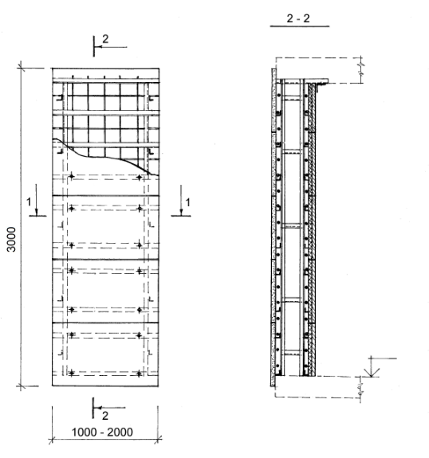
1
2
8
100
7
9
4
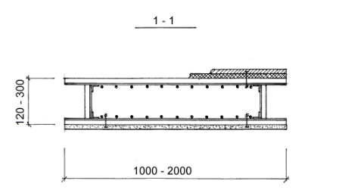
7
8
9
6
9
6
100
110
2

Figure 2. Light hollow wall element, sectional view

The bearing reinforced concrete columns 5 are placed in the hollow space inside the wall elements 1 between the facing slabs.
After finishing erecting the walls the reinforced concrete ceiling slab 4 is erected. As soon as the heavy-weight concrete as reached a preset strength, the next reinforced-concrete ceiling is erected.
The use of the proposed light hollow wall element and of the method of erecting the walls of a building makes it possible, as compared-with known methods, to decrease the labor input of construction work and raise the efficiency of dwelling erection.

REFERENCES
- Sokolov G., Construction Technology, Akademia, 2007 , 544 p.(in Russian).
- Statsenko A., Construction Technology , Feniks, Rostov-na-Donu, 2006, 416 p. (in Russian).
- Figovsky O.L. Futoryansky A. M. Construction of multystoried buildings with monolithic ferroconcrete overlappings by means of combined large-size spatial designs. Inženernyj vestnik Dona (Rus), 2014, №4 p.2. URL: .ivdon.ru/ru/magazine/archive/n4p2y2014/2740. (in Russian).
- Morgun V.N. Reflections about efficiency of the wall materials applied in modern construction. Inženernyj vestnik Dona (Rus), 2014, №4 p.2. URL: ivdon.ru/ru/magazine/archive/n4y2008/97. (in Russian).
- WANDKONSTRUKTION UND VERFAHREN ZU IHRER HERSTELLUNG. Patent DE-2236463. 1973-02-08.
- MANTELBETONWAND Patent. DE-2013630. 1971-11-18,
- IN SITU STRUCTURAL WALL CONSTRUCTION . Patent GB-1599033. 1981-09-30.
- METHOD OF PREFABRICATED CONSTRUCTION AND BUILDING STRUCTURE CONSTRUCTED IN ACCORDANCE WITH SUCH METHOD. Patent IL 61258. 1983-12-30.
- LIGHT HOLLOW WALL ELEMENT AND METHOD OF ERECTING WALLS OF BUILDINGS WITH THE USE OF SUCH ELEMENTS. Patent IL 121081. 2001-08-08.
- Figovsky O.L. et al. Construction element for erecting structure, and method of erecting structure with use thereof. Patent US 8,615,967. 2013-12-31.
- Figovsky O., Beilin D. Advanced Polymer Concretes and Compounds. CRC Press, 2014. 267 p.

